A project report on

CONCURRENT POST-QUANTUM ACCELERATION ON CONSUMER HARDWARE

Submitted in partial fulfillment for the award of the degree of

Bachelor of Technology in Computer Science and Engineering

by
RAVI VENAKTA SAI KARTIK (22BCE1743)
ABHINAV KUSHWAHA (22BCE1746)
AKSHAT VERMA (22BLC1318)



SCHOOL OF COMPUTER SCIENCE AND ENGINEERING

November, 2025

CONCURRENT POST-QUANTUM ACCELERATION ON CONSUMER HARDWARE
Submitted in partial fulfillment for the award of the degree of

Bachelor of Technology in Computer Science and Engineering

by
RAVI VENKATA SAI KARTIK (22BCE1743)
ABHINAV KUSHWAHA (22BCE1746)
AKSHAT VERMA (22BLC1318)



SCHOOL OF COMPUTER SCIENCE AND ENGINEERING

November, 2025



DECLARATION

I hereby declare that the thesis entitled “MEMVIS: PROFILER AND AN EDUCATIONAL TOOL” submitted by ABHINAV KUSHWAHA (22BCE1746), for the award of the degree of Bachelor of Technology in Computer Science and Engineering, Vellore Institute of Technology, Chennai is a record of bonafide work carried out by me under the supervision of DR. Karmel A.
I further declare that the work reported in this thesis has not been submitted and will not be submitted, either in part or in full, for the award of any other degree or diploma in this institute or any other institute or university.

Place: Chennai
Date: Signature of the Candidate



School of Computer Science and Engineering

CERTIFICATE

This is to certify that the report entitled “CONCURRENT POST-QUANTUM ACCELERATION ON CONSUMER HARDWARE” is prepared and submitted by Abhinav Kushwaha (22BCE1746) to Vellore Institute of Technology, Chennai, in partial fulfillment of the requirement for the award of the degree of Bachelor of Technology in Computer Science and Engineering is a bonafide record carried out under my guidance. The project fulfills the requirements as per the regulations of this University and in my opinion meets the necessary standards for submission. The contents of this report have not been submitted and will not be submitted either in part or in full, for the award of any other degree or diploma and the same is certified.

Signature of the Guide:

Name: Dr. Karmel A

Date:

Signature of the Examiner Signature of the Examiner
Name: Name:
Date: Date:

Approved by the Head of Department,
Computer Science and Engineering
Name: Dr. Prassanna J
Date:
ABSTRACT

The paper introduces an innovative approach to enhancing the performance of CRYSTALS-Kyber, a post-quantum cryptosystem, by utilizing AI accelerators, specifically NVIDIA's Tensor Core. The authors identify polynomial multiplication as one of the most computationally intensive tasks in lattice-based cryptography, and they aim to accelerate this operation using Tensor Cores, which are traditionally designed for machine learning tasks. The challenge lies in adapting the cryptographic computations to suit the specialized nature of these accelerators, which are optimized for low-precision arithmetic.

To overcome this, the authors transform cryptographic operations into a matrix multiplication format that Tensor Cores can efficiently process. They also balance precision and performance, experimenting with different data types such as INT8 and FP16, to maintain the correctness of the cryptographic operations while achieving significant performance gains. The resulting implementation shows impressive speedups—about 6.47 times faster than the state-of-the-art on the same hardware. The paper further introduces an "NTT box" that performs the Number Theoretic Transform (NTT) and its inverse (INTT) more efficiently, using precomputed twiddle factor tables to reduce memory access delays.

This implementation is tested on an RTX 3080 GPU and achieves substantial improvements in speed compared to previous CPU and GPU-based implementations, demonstrating the potential of AI accelerators in cryptographic computing. The authors also address security concerns, ensuring that the use of Tensor Cores does not introduce new vulnerabilities and may, in fact, enhance resistance to side-channel attacks. Overall, this work presents a promising framework for using AI accelerators to accelerate post-quantum cryptography, offering a path forward for more efficient cryptographic algorithms in the post-quantum era.

ACKNOWLEDGEMENT

It is my pleasure to express with deep sense of gratitude to Dr. Karmel A,
Professor Grade 1, School of Computer Science and Engineering, Vellore Institute of Technology, Chennai, for her constant guidance, continual encouragement, understanding; more than all, she taught me patience in my endeavor. My association with her is not confined to academics only, but it is a great opportunity on my part of work with an intellectual and expert in the field of Computer Science.
It is with gratitude that I would like to extend my thanks to the visionary leader Dr. G. Viswanathan our Honorable Chancellor, Mr. Sankar Viswanathan, Dr. Sekar Viswanathan, Dr. G V Selvam Vice Presidents, Dr. Sandhya Pentareddy, Executive Director, Ms. Kadhambari S. Viswanathan, Assistant Vice-President, Dr. V. S. Kanchana Bhaaskaran Vice-Chancellor, Dr. T. Thyagarajan Pro-Vice Chancellor, VIT Chennai and Dr. P. K. Manoharan, Additional Registrar for providing an exceptional working environment and inspiring all of us during the tenure of the course.
Special mention to Dr. Viswanathan V, Dean, Dr. Nithyanandam P, Dr. Suganya G, Dr. Sweetlin Hemalatha C, Associate Deans, School of Computer Science and Engineering, Vellore Institute of Technology, Chennai for spending their valuable time and efforts in sharing their knowledge and for helping us in every aspect.
In jubilant state, I express ingeniously my whole-hearted thanks to Dr. Prassanna J, Head of the Department, B.Tech. Computer Science and Engineering and the Project Coordinators for their valuable support and encouragement to take up and complete the thesis.
My sincere thanks to all the faculties and staffs at Vellore Institute of Technology, Chennai who helped me acquire the requisite knowledge. I would like to thank my parents for their support. It is indeed a pleasure to thank my friends who encouraged me to take up and complete this task.
Place: Chennai
Date: Abhinav Kushwaha
Contents
LIST OF FIGURES iv
LIST OF ACRONYMS v
Chapter 1 1
Introduction 1
Objective 1
Literature review 2
Chapter 2 6
Proposed Methodology 6
Chapter 3 23
Pseudocode 23
Chapter 4 37
Testing 37
Scalability 40
Sustainability 41
Reliability 42
Chapter 5 44
Result and Analysis 44
References 74

LIST OF FIGURES
Figure 1(a) 9
Figure 1(b) 10
Figure 1(c) 10
Figure 1(d) 11
Figure 5(a) 54
Figure 5(b) 55
Figure 5(c) 55
Figure 5(d) 57
Figure 5(e) 58
Figure 5(f) 59
Figure 5(g) 60

LIST OF ACRONYMS

- CUDA: Compute Unified Device Architecture
- GUI: Graphical User Interface
- IMGUI: Immediate Mode GUI
- IPC: Instruction Per Cycle
- WMMA: Warp Matrix Multiply and Accumulate

Chapter 1

Introduction, Objective and Literature Review

1.1 INTRODUCTION

Public-key cryptography is a core building block of modern secure communication. Schemes such as RSA and elliptic-curve cryptography are widely deployed because they provide strong security with high performance on commodity hardware. However, the emergence of large-scale quantum computers poses a direct threat to these systems. Shor’s algorithm shows that integer factorization and discrete logarithms can be solved efficiently on a quantum computer, which would render today’s public-key schemes insecure.

To address this threat, the cryptographic community has shifted attention toward post-quantum cryptography (PQC), which is designed to remain secure against both classical and quantum attacks. As part of this effort, the NIST Post-Quantum Cryptography Standardization process selected CRYSTALS-Kyber as the standard public-key encryption and key-establishment algorithm. Kyber is based on lattice assumptions, specifically the Module Learning With Errors (MLWE) problem, which is believed to be resistant to known quantum attacks.

As a result, hardware acceleration is widely seen as essential for making post-quantum cryptography practical at scale. GPUs are particularly attractive for this task due to their massive parallelism and high arithmetic throughput. However, achieving good performance on GPUs is not straightforward. Naïve implementations suffer from excessive global memory traffic, poor data locality, and underutilization of specialized hardware units.

Existing research has explored two largely separate directions to address these issues. One line of work focuses on optimizing Kyber for GPUs using careful memory management, kernel fusion, and improved traversal strategies for the Number Theoretic Transform (NTT), which is the dominant cost in polynomial multiplication. Another line of work investigates the use of AI accelerators—specifically NVIDIA Tensor Cores—to accelerate NTT by reformulating parts of the computation as matrix operations.

This report builds on these two complementary ideas. Motivated by their respective strengths and limitations, we study how kernel-level GPU optimizations and AI-accelerator-based computation can be combined to better exploit consumer-grade GPU hardware for post-quantum cryptography. The goal is not only to improve raw performance, but also to better understand how different GPU execution units can be used concurrently and efficiently for lattice-based cryptographic workloads.

1.2 OBJECTIVE

This project aims to design and implement an optimized solution for accelerating CRYSTALS-Kyber, a lattice-based post-quantum cryptosystem, using AI accelerators, specifically NVIDIA's Tensor Core. The primary objective is to address the computational challenges posed by polynomial multiplication in lattice-based cryptography by transforming it into a format that can be processed efficiently by Tensor Cores. This project seeks to improve the performance of CRYSTALS-Kyber without compromising its security by leveraging the specialized hardware of AI accelerators, traditionally used in machine learning, to speed up the most time-consuming operations in the cryptographic process.

The project will develop a custom "NTT box" that performs Number Theoretic Transforms (NTT) and its inverse (INTT) using Tensor Core's matrix multiplication capabilities. This solution will enable significant speedups in key cryptographic tasks such as key generation, encryption, and decryption, making it a viable solution for real-world post-quantum cryptography applications. Additionally, the project will explore how to balance precision and performance by experimenting with various data types like INT8 and FP16 to maximize the efficiency of Tensor Core operations.

The aim is to create a highly efficient, secure, and scalable implementation of CRYSTALS-Kyber that can serve as a reference for future cryptographic systems. By demonstrating the power of AI accelerators in accelerating cryptographic operations, this project seeks to contribute to the development of next-generation cryptography, specifically in the context of post-quantum algorithms. Ultimately, the project will provide an innovative solution for accelerating lattice-based cryptosystems, showcasing how AI hardware can be leveraged to meet the performance demands of modern cryptographic applications.

  - LITERATURE REVIEW

This section reviews prior work relevant to accelerating lattice-based post-quantum cryptography, with a focus on CRYSTALS-Kyber. The literature is grouped by platform and optimization strategy, and citations are numbered according to first appearance, following IEEE conventions. All cited works are drawn exclusively from the reference list provided in the project PPT.

1.3.1 FOUNDATIONS OF LATTICE-BASED CRYPTOGRAPHY AND KYBER
The modern development of post-quantum public-key encryption culminated in the selection of CRYSTALS-Kyber by NIST in 2022. Avanzi et al. describe the finalized Kyber design, its parameter sets, and security rationale based on the Module Learning With Errors (MLWE) problem, along with improvements in noise handling and ciphertext compression [1]. This work establishes Kyber as the reference lattice-based KEM and motivates the need for efficient implementations across platforms.

At a systems level, Kyber’s performance is dominated by polynomial arithmetic over the ring R_q = Z_q[X]/(X^256 + 1). The repeated use of the Number Theoretic Transform (NTT) in key generation, encryption, and decryption makes it the primary optimization target across all implementations.

1.3.2 CPU AND SIMD-BASED OPTIMIZATIONS
Initial performance improvements for Kyber focused on software optimization on CPUs. Hwang et al. demonstrate high-speed NTT implementations using AVX2 instructions, confirming that vectorization can significantly reduce latency for polynomial multiplication [2]. Similar ideas were explored on ARM platforms, where Nguyen et al. apply SIMD techniques to improve Kyber performance, although gains remain limited compared to massively parallel platforms [3]. Becker et al. further show that NEON SIMD instructions can accelerate Kyber on ARM CPUs, but these approaches are inherently restricted to specific instruction sets and processor families [4]. Collectively, CPU-based optimizations improve baseline performance but face hard limits due to restricted parallelism and memory bandwidth.

1.3.3 EMBEDDED AND ARM-FOCUSED IMPLEMENTATIONS
Several works target Kyber deployment on constrained devices. Alkim et al. present software optimizations for microcontrollers, improving efficiency but falling short of requirements for large scale or high-throughput applications [5]. Abdulrahman et al. extend this line of work by refining embedded optimization techniques for Cortex-M platforms, with a strong focus on low power consumption rather than raw speed [6].

Botros et al. optimize Kyber for ARM Cortex-M4 processors, demonstrating feasibility in embedded settings while highlighting the trade-off between performance and generality [7]. Sanal et al. further optimize Kyber for ARM64 systems using faster NTT routines and AES hardware acceleration, though these techniques remain hardware-specific [8]. While these works are essential for IoT and edge devices, their design constraints limit applicability to high-throughput environments.

1.3.4 GPU ACCELERATION USING CUDA CORES
GPUs offer large-scale parallelism and have therefore attracted attention for accelerating lattice-based cryptography. Gupta et al. present one of the earliest CUDA-based Kyber accelerators, optimizing subfunctions such as NTT and Keccak, but suffering from high global memory traffic [9]. Lee et al. explore fine-grained parallelization strategies for NTT on RTX GPUs, demonstrating improved utilization but limited scalability across Kyber parameter sets [10]. Ji et al. significantly advance GPU-based Kyber acceleration through the HI-Kyber framework [11].

Their work introduces kernel fusion to eliminate unnecessary global memory accesses and proposes depth f irst NTT traversal strategies such as SLM, SDFS-NTT, and EDFS-NTT. These techniques dramatically reduce memory traffic and maximize register reuse, enabling million-level key exchange throughput on consumer GPUs. Despite these gains, HI-Kyber primarily utilizes CUDA cores and does not leverage specialized AI accelerators.

1.3.5 AI ACCELERATORS AND TENSOR-CORE-BASED APPROACHES
Recent GPUs incorporate AI accelerators, most notably Tensor Cores, which provide extremely high throughput for matrix multiply-and-accumulate operations. Wan et al. propose mapping Kyber’s NTT computations to Tensor Cores using low-precision arithmetic and the WMMA programming model [12].

This approach demonstrates that Tensor Cores can be repurposed for cryptographic workloads, achieving substantial speedups for polynomial multiplication. An earlier framework by Wan et al. further generalizes this idea by exploring how lattice-based cryptographic workloads can be expressed for AI accelerators, though at the cost of complex data transformations and careful precision management [13].

These works show the potential of AI accelerators but focus primarily on isolated NTT acceleration rather than full-pipeline optimization. Complementary arithmetic optimizations are explored by Plantard, who proposes improved modular reduction techniques tailored for small moduli such as q = 3329, reducing the cost of modular multiplication in PQC schemes [14].

1.3.6 SUMMARY AND IDENTIFIED GAP
Across the literature, a clear progression is visible: CPU vectorization improves baseline performance, embedded implementations prioritize efficiency and power, GPU CUDA-core designs address parallelism and memory locality, and Tensor-Core approaches unlock new levels of arithmetic throughput. However, no single work fully integrates system-level GPU optimizations with AI accelerator-based computation.

CUDA-core-centric designs such as HI-Kyber excel at kernel fusion and memory efficiency, while Tensor Core-based designs offer unmatched performance for NTT. This separation motivates the approach explored in this report, which seeks to combine both strategies to better utilize heterogeneous GPU hardware for post-quantum cryptography.

Chapter 2

Proposed Methodology

2.1 METHODOLOGY DISCUSSION

This project presents a novel approach to accelerating lattice-based cryptography, specifically the CRYSTALS-Kyber post-quantum cryptosystem, using AI accelerators, namely NVIDIA's Tensor Cores. The aim is to transform the computationally intensive polynomial multiplication within Kyber into a form that can be processed efficiently by these AI-specific hardware components, traditionally optimized for machine learning tasks. The methodology focuses on leveraging the exceptional matrix multiplication capabilities of Tensor Cores to improve performance while ensuring the cryptographic operations retain their correctness. This transformation involves adapting the polynomial operations, particularly the Number Theoretic Transform (NTT), into a matrix multiplication format suitable for Tensor Cores, thereby achieving significant acceleration in cryptographic computations.

The core challenge is adapting the polynomial multiplication and NTT operations, typically designed for general-purpose processors, to fit the highly specialized and low-precision arithmetic of Tensor Cores. Tensor Cores, designed for matrix operations and low-precision computations, are ideally suited for the high parallelism required in polynomial multiplication, but transforming cryptographic operations into an AI-compatible format requires careful adjustments. The authors address this challenge by developing a custom "NTT box" that performs NTT and its inverse (INTT) in an efficient manner using CUDA C++ WMMA APIs. The proposed solution exploits multiple precision formats such as INT8 and FP16 to strike a balance between computational efficiency and precision.

The methodology also integrates precomputed twiddle factor tables, which help accelerate the NTT process by eliminating redundant calculations during the transformation. By organizing polynomial coefficients into matrices and utilizing Tensor Cores' matrix-multiply-and-add (MMA) capabilities, the method enables simultaneous processing of multiple polynomials in parallel. The NTT box utilizes precomputed tables for twiddle factors, which are loaded into memory to reduce latency, making the process more efficient. This design eliminates costly memory access delays, significantly improving the overall performance of polynomial multiplication in Kyber.

Empirical results show that the proposed method achieves substantial speedups, including a 6.47x improvement over the state-of-the-art implementation on the same GPU platform. Compared to the AVX2-based implementation, the Kyber-1024 parameter set shows speedups of 26x, 36x, and 35x in key generation, encryption, and decryption, respectively. These results underscore the potential of AI accelerators like Tensor Cores in accelerating post-quantum cryptography, particularly in lattice-based cryptographic schemes such as Kyber.

The methodology also addresses key security considerations, particularly against side-channel attacks. The use of Tensor Cores, which are not susceptible to traditional timing attacks due to their parallel execution model, mitigates risks associated with side-channel vulnerabilities. The system also incorporates defense mechanisms against timing leaks by eliminating secret-dependent conditional branches in the CUDA kernels, further enhancing the security of the cryptographic implementation.

This project is implemented in four stages. The first phase involves adapting CRYSTALS-Kyber to leverage Tensor Cores for polynomial multiplication. In the second phase, the integration of precomputed tables and memory optimizations is introduced to further enhance performance. The third phase involves testing the solution with larger parameter sets, such as Kyber-768 and Kyber-1024, to evaluate scalability. The final phase refines the system by optimizing memory access patterns and exploring further use of AI accelerators for other cryptographic primitives. This phased approach allows for a systematic evaluation of the proposed methods and ensures that each step contributes effectively to the overall performance improvement.

2.1.1 PHASE 1: INITIAL CRYSTALS-KYBER ACCELERATION WITH TENSOR CORES

The first step in this methodology is to implement a baseline solution by adapting CRYSTALS-Kyber to use NVIDIA’s Tensor Core for accelerating polynomial multiplication. The primary goal in this phase is to establish a functional implementation that uses Tensor Cores’ matrix multiplication capabilities to replace traditional CPU-based operations. The first task involves converting the polynomial multiplication process into a matrix format that can be efficiently processed by the Tensor Core architecture. This transformation is done by adapting the NTT computation, traditionally used in lattice-based cryptography, into matrix multiplications compatible with Tensor Cores.

To do this, the polynomials involved in Kyber's cryptographic operations are organized into matrices, and the twiddle factors necessary for the NTT operation are precomputed and stored. The core component of this phase is the development of the NTT box, a custom module that implements the NTT and INTT operations using the tensor-specific matrix multiplication and accumulation features of the Tensor Cores. The results of this phase will serve as a foundation for the subsequent phases, providing a working version of the system that demonstrates the feasibility of using Tensor Cores for lattice-based cryptography.

2.1.2 PHASE 2: INTEGRATING PRECOMPUTED TABLES AND OPTIMIZING MEMORY ACCESS
In the second phase, the focus shifts to optimizing the system by incorporating precomputed twiddle factor tables and fine-tuning memory access patterns. The precomputed tables allow for the fast retrieval of twiddle factors during the NTT operation, eliminating the need for repeated calculations. This reduces the overall computation time and enhances the performance of the system. Additionally, optimizations are made to ensure that the memory access patterns are aligned with Tensor Core’s capabilities, minimizing memory latency and ensuring that the polynomial data is efficiently loaded into the accelerator.
A key part of this phase is the integration of specialized memory management techniques that ensure data is organized and accessed in a way that maximizes throughput. This phase also includes profiling and benchmarking to evaluate the performance gains achieved through these optimizations. By the end of this phase, the system will demonstrate a fully optimized pipeline that can process larger parameter sets more efficiently.

2.1.3 PHASE 3: SCALABILITY TESTING WITH LARGER PARAMETERS

The third phase focuses on testing the scalability of the implementation with larger parameter sets such as Kyber-768 and Kyber-1024. In this phase, the system is evaluated under different cryptographic workloads to understand how well it handles increasing computational complexity. The goal is to verify whether the optimizations made in the previous phases hold up as the size of the cryptographic tasks grows.

Scalability tests will involve measuring the performance of key operations like key generation, encryption, and decryption across a range of parameter sizes. The results will help assess the effectiveness of the proposed solution in real-world cryptographic scenarios, where larger parameters are required for higher security levels. Any performance bottlenecks identified during this phase will be addressed in the next iteration of optimization.

2.1.4 PHASE 4: FINAL OPTIMIZATIONS AND SECURITY ENHANCEMENTS

The final phase will refine the implementation by further optimizing memory access, reducing latency, and integrating advanced security measures. This phase will involve enhancing the security of the implementation by incorporating defenses against side-channel attacks, such as timing attacks, by ensuring that the execution paths are constant-time and independent of sensitive data. Additionally, further optimizations will be made to improve the throughput and minimize any remaining inefficiencies in the system.

In this phase, the system will also undergo comprehensive testing to validate its robustness, performance, and security. The final deliverable will be a highly efficient, secure, and scalable cryptographic implementation that demonstrates the power of AI accelerators in accelerating post-quantum cryptography.

2.2 PROPOSED ARCHITECTURE DIAGRAM

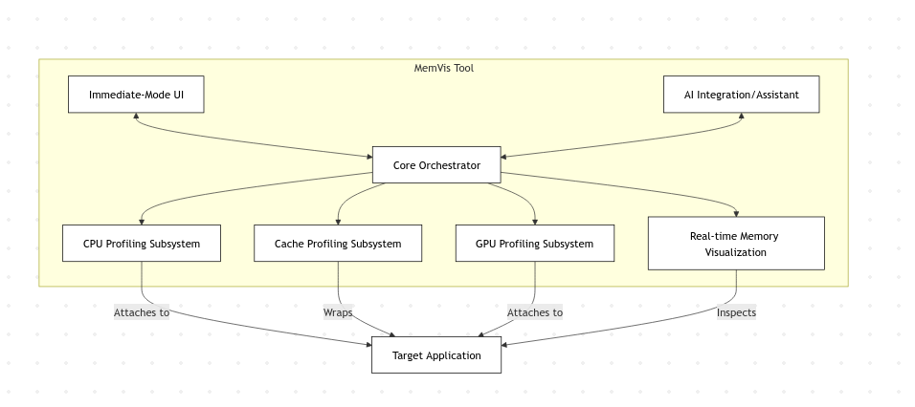Figure 1(a) Proposed Architecture: Over-all architecture of MemVis.

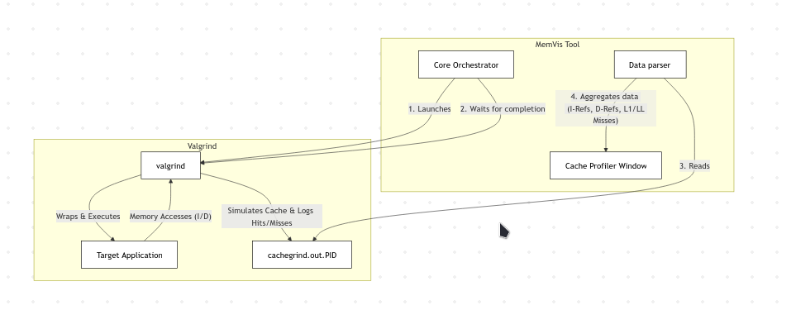

Figure 6(b) Proposed Architecture: Cache Profiler.
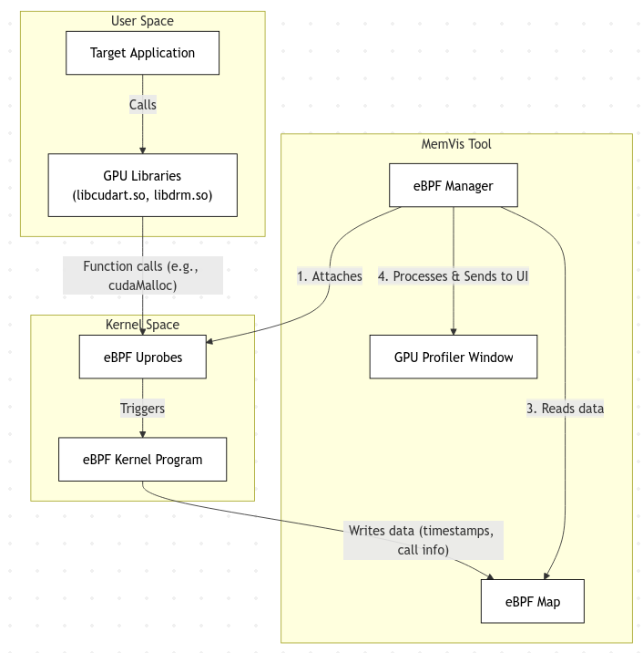
Figure 1(c) Proposed Architecture: GPU profiler

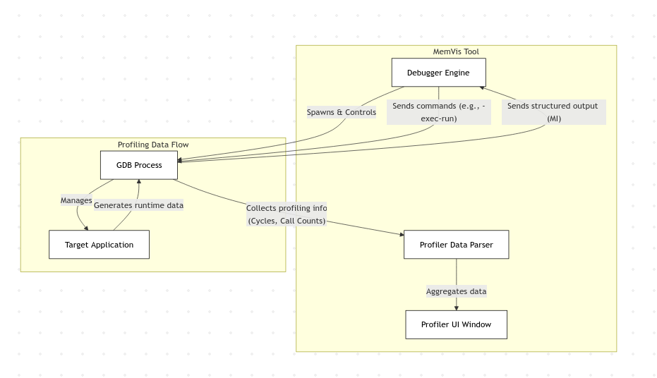
Figure 1(d) Proposed Architecture: CPU profiler.

2.3 PROPOSED ARCHITECTURE EXPLANATION

There is always a need for performance in today's software development world. Programs need to be able to handle huge amounts of data in real time, use advanced hardware like GPUs, and have a user interface that is always responsive. In this case, performance analysis and debugging tools are no longer nice to have; they are now a must-have. Still, standard debugging tools are good for controlling programs, but they don't work well for performance analysis. Most of the time, they are made on monolithic designs that combine program control with data measurement. This makes for a frustrating user experience with too many UI freezes and a basic inability to see how a program works. This design bottleneck forces developers to make an unpleasant choice: they can either profile the program or control it, but they can't do both well at the same time.

The MemVis Tool's main innovation is its combination architecture, which is a bottom-up rethinking of the debugging and profiling approach that aims to solve long-standing problems with performance, interactivity, and insight. The physical and logical separation of the program control task from the performance data collection task is the most important part of this architecture. MemVis has a bifurcated, dual-path architecture, while traditional visual debuggers are architecturally monolithic. For example, GDB uses the ptrace system call to control the program's execution and ask about its state and performance at the same time. This design creates two separate and parallel operational paths: a "Slow Path" for explicit, low-frequency program control and a "Fast Path" for quickly and easily collecting performance data with little overhead.

The strength of this tool comes from the way it is built. The Slow Path follows the intentional, high-latency quality of traditional debugging for tasks that require the application to be paused, like installing breakpoints or checking memory. It uses the GDB/MI interface, which is the industry standard for these tasks. On the other hand, the Fast Path is asynchronous and parallel. It uses advanced, high-speed technologies like eBPF and optimized file parsing to get a full stream of performance data from the running application without affecting it at all. This separation makes sure that the UI's performance gauges are always up to date and moving in real time, even when the target app is running at native speed or in Slow Path mode for a long, synchronous operation. This gives the user a steady stream of information without any annoying interface freezes that happen with older tools. This makes for a much more informed and productive development experience. This document will now give a thorough and in-depth look at each part of this new architecture.

2.3.1 THE SLOW PATH: THE GDB/MI FOUNDATIONAL CONTROL PLANE
The Slow Path is the first and most important part of the MemVis architecture. It is the tool's main control plane. This path is specifically made to handle all user-directed actions that need precise control over the execution state of the target application. Setting and removing breakpoints, stepping through code line by line, looking at the call stack, and looking at the values of variables in memory are all actions that are, by their very nature, planned and break the flow of the program. For these tasks, speed isn't as important as accuracy and control. This path is based on the strong and widely used GNU Debugger (GDB) and its Machine Interface (MI). This architectural choice makes use of GDB's decades of development and its power as a control agent on purpose, while also strategically separating its main weakness—its latency when used for data collection—from the parts of the tool that are sensitive to performance.

2.3.1.1. THE DEBUGGER ENGINE (GDM.H): A ROBUST GDB INTERMEDIARY
The Debugger Engine, a complex C++ class that is part of the gdm.h component, is at the heart of the Slow Path. This engine is the only way for the MemVis user interface to talk to the GDB backend. It is in charge of managing all communication and the entire lifecycle of a GDB session. The user starts the process by loading a target app. The Debugger Engine makes a new child process and runs GDB inside of it. Most importantly, it sends GDB's standard input, output, and error streams to a group of pipes. MemVis uses these pipes as its own private communication channel to control things.

The GDB/MI protocol, specifically version MI2 or later, is the only way to communicate. The Machine Interface is a line-based, text-based protocol made just for programmatic interaction. This sets it apart from the interactive command-line interface, which is made for people. MI commands start with a token and a hyphen (for example, -exec-run or -break-insert), and GDB's answers are structured and tagged so that they can be easily parsed. An answer can be a result record (^done), a status record (*running), an error message (^error), or an out-of-band notification (=thread-created). This structured communication is very important for making a front-end that works.

The Debugger Engine's main job is to manage communication between the user interface and the GDB backend in a complex, multi-layered way. The first thing it does is command translation. It takes high-level user actions from the UI, like when a user clicks "add a breakpoint at line 52," and turns them into the correct Machine Interface (MI) command, like 1-break-insert main.c:52. The "1" in this command is a unique token that is very important for the engine's second main function, which is handling responses asynchronously. GDB works asynchronously by nature. For instance, when you send a command like -exec-continue, GDB might not respond for a long time, only doing so when the program hits a breakpoint or is otherwise interrupted. The Debugger Engine does a great job of this by using an event loop that doesn't block. This loop keeps an eye on GDB's stdout pipe and parses incoming messages as they come in, all without stopping the rest of the application. It also keeps track of all the tokens that have been sent and their outstanding commands, which lets it correctly link these delayed, incoming result records to the original requests that started them.

The third job of the Debugger Engine, which is to keep the internal state in sync, is probably the most important part of its design. The engine keeps its own internal, synchronized model of the debuggee's state instead of constantly asking GDB for information, which would be very slow and wasteful. It does this by listening for GDB's notifications that aren't part of the main stream. For example, GDB sends a *stopped notification when the program stops. This one message has a lot of information, like the reason for the stop (for example, a breakpoint hit or a signal received), the current thread, and the exact stack frame. The engine parses this event, updates its internal state model to show that the program has stopped, and then, if necessary, sends follow-up commands to get more information, such as the values of local variables or the full call stack. This event-driven method, which puts listening for state changes ahead of active polling, cuts down on the number of synchronous, blocking requests by a huge amount. This cut is absolutely necessary to keep the application's control path responsive, which is important for keeping the user experience smooth.

This whole thing is very powerful for control, but it has a big problem: the ptrace system call that GDB uses under the hood is very slow (on Linux). It takes a long time to stop, switch contexts, and look at the target process for every interaction. MemVis is architecturally brilliant because it accepts this limit and separates it from the high-speed world of performance data collection. This way, the necessary slowness of debugging control doesn't get in the way.

2.3.2 THE FAST PATH: ASYNCHRONOUS HIGH-FREQUENCY DATA ACQUISITION
The Fast Path runs at the same time as and separately from the Slow Path. It is the main part of MemVis that makes it possible to see performance in real time. The people who built this path had one main goal in mind: to keep costs low. Its only job is to gather a lot of high-frequency performance data from the target application while it runs at or near native speed. It does this by using a set of advanced, low-impact technologies that can look at the application's behavior from the user-space libraries it calls to the kernel events it triggers. There are several specialized subsystems in the Fast Path, and each one focuses on a different part of application performance. The UI layer gets data from these subsystems directly and asynchronously, without going through the GDB control plane. This makes sure that the performance graphs and metrics stay responsive and show the most recent data even if the user has stopped the application in the debugger or is waiting for a slow variable inspection to finish.

2.3.2.1. THE CPU PROFILING SUBSYSTEM: A HYBRID KERNEL AND USER-SPACE APPROACH
To analyze performance, you need to know how the CPU works. The CPU Profiling Subsystem in MemVis uses a smart hybrid approach that combines the deep kernel insight of eBPF with the ease of use and accessibility of the /proc filesystem. This two-pronged approach gives a complete picture of CPU activity by gathering both high-frequency, event-driven data and periodic, state-based metrics.

eBPF for tracing high-frequency kernel events:
The extended Berkeley Packet Filter (eBPF) is the main tool for CPU profiling. eBPF is a groundbreaking kernel technology that makes it possible to safely and quickly load and run small, sandboxed programs directly in the Linux kernel. MemVis can attach probes to thousands of different kernel functions and tracepoints, which makes the kernel itself a data source. The CPU Profiling Subsystem compiles and loads eBPF programs that track important performance-related events linked to the target application's process ID (PID) using a framework like BCC (BPF Compiler Collection) or libbpf.

The subsystem pays a lot of attention to Context Switches and Page Faults, which are two of the most important events that are tracked. An eBPF program is carefully linked to the finish_task_switch kernel function to keep an eye on Context Switches. This hook lets the subsystem keep track of every time the target process is scheduled to run on or off of a CPU core. This information is very helpful for finding performance problems that are hard to find, like too much thread contention, priority inversion, or bad CPU cache affinity. This tracing is very important because frequent, unintentional context switches are widely known to be a major cause of system overhead and performance problems.

At the same time, the subsystem tracks Page Faults by adding another eBPF program to the handle_mm_fault tracepoint in the kernel. This system can keep track of all the minor (when the page is in memory but not mapped) and major (when the page must be read from disk) page faults that the target application makes. A lot of these faults is a very strong sign that there are performance problems that need to be fixed. It often shows that the system is under a lot of memory pressure or that the application's code is accessing memory in an inefficient way, like not using data locality. This gives you a direct and detailed look at how the app is using the virtual memory subsystem.

These eBPF programs don't send the data they collect (like timestamps and event counts) to user-space through slow system calls. Instead, it goes into per-CPU eBPF maps that are very efficient and don't need to be locked, like perf buffers or ring buffers. The profiling subsystem's user-space part can then read from these buffers asynchronously with very little delay. This lets it update the UI with information about kernel-level events that is almost real-time without ever stopping the target process.

For estimating hardware counters, use the /proc filesystem:
eBPF is great for tracing events, but getting to some hardware performance counters, like the total number of CPU cycles that have passed, can be hard or require higher permissions. The subsystem periodically reads the /proc/[pid]/stat file with little impact to add to the eBPF data. The kernel keeps this virtual file, which has a lot of statistics about processes. The subsystem can figure out how much CPU the target process is using over time by reading values like utime (user mode time) and stime (kernel mode time) at regular intervals, like every 200ms. This polling-based method has higher latency and lower resolution than eBPF's event-based tracing. However, it gives you important top-level metrics with almost no extra work, which is a great addition to the fine-grained eBPF data. When developers use both of these methods, they can see how their app's CPU works on both a large and small scale.

2.3.2.2. The GPU Profiling Subsystem: Using eBPF Uprobes to Look Inside User Space

As GPU computing becomes more common, profiling GPU interactions is no longer an option. Most traditional GPU profilers are heavy, vendor-specific tools that need the application to be run in a special mode and can slow down performance by a lot. Using eBPF uprobes, the MemVis architecture takes a very different, lighter approach.

A uprobe (user-space probe) is a dynamic instrumentation point that can be added to any function in a shared library or user-space application. The GPU Profiling Subsystem uses this to keep track of how the target application interacts with the GPU driver stack without getting in the way. It doesn't add uprobes to the application binary itself; instead, it adds them to important functions in the standard GPU libraries that the application links to, like libcudart.so (for CUDA applications) or libdrm.so (for direct rendering).

The process of profiling a GPU is both simple and effective, starting with the Attachment phase. When a profiled run starts, the eBPF Manager first finds the target process and then dynamically attaches uprobes to certain high-interest functions in its address space. Profiling a GPU usually means looking at functions in the CUDA runtime library, libcudart.so, like cudaMalloc (for allocating memory), cudaMemcpy (for moving data), and cudaLaunchKernel (for starting computations).
Once attached, the process goes straight to Triggering and Data Collection. When the target application runs and calls one of these hooked functions (like cudaMalloc), the flow of execution is briefly and invisibly sent to the kernel before the actual code for the function runs. The eBPF kernel program that goes with the uprobe is running right now. This program has special access to the call's context, which lets it get the process ID, thread ID, and even the function's arguments. For instance, it can read the size parameter from the cudaMalloc call or the count from the cudaMemcpy call. It keeps track of all this important information and adds a timestamp with high accuracy.

Data Transfer then takes care of this captured data. The eBPF program puts the information it collects into an eBPF map. This map, like the CPU profiler, is a very fast, very efficient, lock-free way for the kernel to talk to user-space. This design makes it possible for the last step, Visualization, to happen in real time. The UI's GPU Profiler Window reads data from this eBPF map in the background and all the time. It updates its display as new data comes in, giving the user a detailed, live-updating timeline of all GPU API calls, memory transfers, and kernel launches as they happen.

This method is revolutionary because it lets you profile a GPU with almost no extra work on the target application itself. The application runs without any changes, and it only takes a few nanoseconds to hit an uprobe. This lets developers see exactly how their app is using the GPU, find slow spots in data transfer, and look at kernel launch patterns, all while the app is running at full speed.

2.3.2.2. THE GPU PROFILING SUBSYSTEM: USER-SPACE INTROSPECTION WITH EBPF UPROBES
As GPU computing becomes more prevalent, the ability to profile GPU interactions is no longer optional. Traditional GPU profilers are often heavyweight, vendor-specific tools that require the application to be launched in a special mode and can introduce significant performance overhead. The MemVis architecture takes a radically different, more lightweight approach by using eBPF uprobes.

A uprobe (user-space probe) is a dynamic instrumentation point that can be attached to any function within a user-space application or shared library. The GPU Profiling Subsystem leverages this to non-intrusively monitor the target application's interactions with the GPU driver stack. Instead of instrumenting the application binary itself, it attaches uprobes to key functions within the standard GPU libraries that the application links against, such as libcudart.so (for CUDA applications) or libdrm.so (for direct rendering).

The workflow for GPU profiling is both elegant and efficient, beginning with the Attachment phase. When a profiled run begins, the eBPF Manager first identifies the target process and dynamically attaches uprobes to specific, high-interest functions within its address space. For GPU profiling, this typically targets functions in the CUDA runtime library, libcudart.so, such as cudaMalloc (for memory allocation), cudaMemcpy (for data transfers), and cudaLaunchKernel (for starting computations).
Once attached, the process moves seamlessly into Triggering and Data Collection. As the target application executes and inevitably calls one of these hooked functions (like cudaMalloc), the execution flow is momentarily and transparently diverted to the kernel before the function's actual code is executed. At this precise moment, the eBPF kernel program associated with the uprobe runs. This program has privileged access to the context of the call, allowing it to capture the process ID, thread ID, and even the function's arguments—for example, it can read the size parameter from the cudaMalloc call or the count from cudaMemcpy. It records all this valuable information along with a high-precision timestamp.

This captured data is then handled via Data Transfer. The eBPF program writes the collected information into an eBPF map. As with the CPU profiler, this map serves as a highly efficient, high-speed, lock-free communication channel from the kernel to user-space. This design is what enables the final step, Visualization, to occur in real-time. The GPU Profiler Window in the UI asynchronously and continuously reads the data from this eBPF map. As new data streams in, it updates its display, presenting the user with a detailed, live-updating timeline of all GPU API calls, memory transfers, and kernel launches as they are happening.

This technique is revolutionary because it provides process-specific, high-context GPU profiling with almost zero overhead on the target application itself. The application runs completely unmodified, and the cost of hitting a uprobe is measured in mere nanoseconds. This allows developers to see exactly how their application is interacting with the GPU, identify bottlenecks in data transfer, and analyze kernel launch patterns, all while the application is running at full speed.

2.3.2.3. THE CACHE PROFILING SUBSYSTEM: DEEP OFFLINE MEMORY ACCESS ANALYSIS WITH VALGRIND
eBPF can give us some information about how memory works by looking at page faults, but it can't show us the small details of how the CPU cache works. The MemVis architecture has a special Cache Profiling Subsystem that lets it give this level of detail for the first time. This subsystem is architecturally unique within the tool because it is designed for offline analysis based on sessions. This is a deliberate design choice because the tool that got this data, Valgrind's Cachegrind, is very powerful but also slows things down a lot (usually by 20 to 100 times). It would be impossible to add such a tool to the real-time Fast Path.

The cache profiling workflow is a planned and self-contained process. It starts when the user chooses "Cache Profile Run" from the MemVis UI, which is different from a regular "Profiled Run." This starts the Execution under Valgrind, where the Core Orchestrator starts the target application, but not directly. It starts the Valgrind instrumentation framework and loads the specific Cachegrind tool by adding valgrind --tool=cachegrind to the command. This tool then starts its Simulation and Logging phase, wrapping every memory access made by the application, including instruction fetches and data reads/writes, with dynamic binary instrumentation. Cachegrind simulates a configurable CPU cache hierarchy while the program runs (though very slowly because of the overhead). This usually includes an L1 instruction cache, an L1 data cache, and a final Last-Level (LL) cache. It keeps track of every memory access very carefully to see if it was a cache hit or miss. It then puts all of this information together and sends it to a log file called cachegrind.out.PID.

Then the process moves on to the analysis phase, which starts with Completion and Parsing. The Core Orchestrator waits for the target application to finish, and then Valgrind finishes the log file. The orchestrator then tells the Data Parser part to do something. This parser is made just for Data Aggregation and Display. It can read and understand the Cachegrind output file's structured format. It gets a lot of information, such as the total number of instruction references (I-Refs), data reads and writes (D-Refs), and most importantly, the specific miss counts for each level of the simulated cache (I1 misses, D1 misses, and LL misses). The parser collects and sends this data to the Cache Profiler Window, which is often given on a per-function or even per-source-line basis. This brings us to the last step: Insightful Visualization. The UI makes this complicated data easy to understand by putting it in tables and charts that show which functions or lines of code cause the most cache misses right away. This information is very helpful for tuning performance because it can directly lead to code refactoring that improves data locality (for example, changing data structures from an array-of-structures to a structure-of-arrays), which can make things go much faster.

MemVis gives you access to the best memory access analysis by treating cache profiling as a separate, offline mode. This doesn't hurt the real-time, low-overhead philosophy of its main profiling mode.

2.3.3 THE UNIFIED UI AND CORE ORCHESTRATOR
The Slow Path and the Fast Path, along with all of their subsystems, show how MemVis can collect and control data. The UI Layer, which is managed and coordinated by the central Core Orchestrator, is what brings all of these different parts together into a single, useful tool. This layer is in charge of showing the user all of the information that has been collected in a way that is both easy to understand and quick to respond to.

2.3.3.1. THE UI LAYER: A MODULAR DESIGN WITH DEAR IMGUI
The Dear ImGui library is used to make the whole front end of MemVis. This is a smart technological choice that fits perfectly with the project's goal of making an interface that responds quickly. ImGui is a library for graphical user interfaces that works in "immediate mode." An immediate-mode UI is different from traditional "retained-mode" frameworks like Qt or WPF because it builds a new tree of widget objects every frame. The main loop of the application code just makes a series of drawing calls, like ImGui::Begin("My Window"); ImGui::Text("Hello"); ImGui::End();.

There are many benefits to using this immediate-mode method for a tool like MemVis, starting with raw performance. ImGui is very small and fast, and it doesn't use much CPU or memory. This is a very important feature that makes sure the profiling UI itself doesn't slow down the application being profiled or mess up the measurements it is trying to show.

This method not only speeds things up, but it also gives you a lot of Simplicity and Flexibility because of the immediate-mode paradigm. This design makes the code needed to make complex, dynamic interfaces much easier. Developers don't have to deal with complex internal state graphs, register callbacks, or keep track of event listeners like they do with traditional retained-mode systems. The UI is just a direct result of the application's current data, which is redrawn from scratch every frame. This makes it easy to change complex tables and graphs in real time because they can show the new data coming in from the tool's Fast Path without any complicated synchronization logic.

Finally, the architecture is based on the idea of modularity. A central debugger_layout.h component controls the whole UI. This layout manager makes the main ImGui context and then calls the render functions of each independent sub-window on each frame. Profiler_window.h, cacheprofiler_window.h, breakpoint_window.h, and ai_window.h are all examples of sub-windows that are completely separate from each other. Each unit is in charge of its own layout and showing its own part of the application's state. This clear division of responsibilities makes it very easy to maintain, debug, and add new features to the entire UI codebase.

2.3.3.2. THE CORE ORCHESTRATOR
The Core Orchestrator is the brain of the application and the UI layer is in charge of how things look. It is a non-visual part that serves as the main link between all of the backend subsystems and the front-end UI.

The Core Orchestrator is like the brain of the whole application, and it has a lot of important jobs to do. To start, it takes care of all Lifecycle Management. This means that the orchestrator is in charge of the lifecycle of all the other main parts. It is in charge of starting the Debugger Engine and the target application. This launch process is flexible because it can happen directly, through the GDB debugger, or with the Valgrind instrumentation framework. The orchestrator also controls the important attaching and detaching of the eBPF profiling subsystems, making sure they are only active when they are needed.

Second, it is the main message bus for Inter-Component Communication, which is what it does. When the user clicks the "Profile Run" button in the UI, this is a clear example of what I mean. The Core Orchestrator gets this event right away. The orchestrator then sends two commands at the same time: it tells the Debugger Engine to send the -exec-run command to GDB and, just as importantly, it tells the eBPF managers to attach their probes to the new process. This second command can't happen until the orchestrator gets the new process ID (PID) from the Debugger Engine. This shows how it manages complicated, dependent command sequences.

Third, the orchestrator is in charge of all data routing. It makes sure that the different streams of data that come from the "Fast Path" (the high-speed eBPF collectors) are sent to the right data models. The UI windows then use these models to draw. This routing is very specific. The orchestrator makes sure that the high-frequency eBPF data is sent to the CPU and GPU profiler windows in the most efficient way possible. At the same time, the parsed data from Valgrind is sent to the Cache Profiler window in the right way.

Lastly, the architecture has a forward-looking AI Integration part. The Core Orchestrator would be in charge of sending this AI engine the rich, aggregated performance data, like high cache miss rates from the cache profiler or frequent context switches from the eBPF probes. The AI engine could then use this information to give the user proactive insights and optimization suggestions. These would be sent back to the user through the dedicated ai_window.h UI element, completing the feedback loop.

The Core Orchestrator is what holds the whole architecture together. It makes sure that the Slow and Fast Paths can work together without any problems and that the UI always has access to the most up-to-date state and performance data.

2.3.4 A COMPLETE USER SESSION: SYNTHESIZING THE ARCHITECTURE IN PRACTICE
To really understand how this decoupled architecture works together, it helps to go through a typical user session and see how the different parts work together to make the experience smooth and informative.

Step 1: Getting Ready and Loading
The user starts MemVis and opens an executable file they want to work on. The Core Orchestrator gets this request from the UI. The orchestrator creates the Debugger Engine, which then starts a GDB child process and sends it the MI command to open the file . The symbol information is loaded by GDB. The UI asks the engine for information about the source files and shows the code in a window called the source viewer. At this point, the Slow Path is the only one that is active.

Step 2: Putting in a Breakpoint
The user clicks in the gutter of the source viewer to set a breakpoint on a line. The UI picks up this event and tells the Debugger Engine about it. The engine changes this into a -break-insert : MI command and sends it to GDB. GDB confirms that the breakpoint has been made, and the engine updates its internal state model. The UI, which is based on this model, puts a red dot on the line that goes with it. The Slow Path is the only one that can do this whole interaction, which is a classic, planned debugging operation.
Step 3: Starting a Profiled Run
The first step in the whole process is Step 3: Initiating a Profiled Run. This happens when the user clicks the "Profiled Run" button. This one action is what makes the tool's dual-path architecture work. The UI sends a message to the Core Orchestrator, which then sends out two sets of instructions at the same time. For the Slow Path, it tells the Debugger Engine to send the -exec-run command to GDB. GDB then starts the target application and runs it. At the same time, the orchestrator gets the target application's new Process ID (PID) from the Debugger Engine for the Fast Path. Then, it gives this PID to the CPU and GPU Profiling Subsystems. The eBPF Managers in these subsystems load their eBPF programs into the kernel right away and attach the right kprobes and uprobes to this PID. This starts the high-speed data collection right away.

Step 4: Working in Real Time and in Parallel
This brings us to Step 4: Real-Time, Parallel Operation. At this point, the target application is running at full speed, and the two paths are working on their own. As the application runs code, allocates memory, and makes calls to the GPU on the Fast Path, the eBPF probes that are connected to it are always going off in the kernel. This creates a fast stream of performance data that goes from the kernel-space eBPF maps to the MemVis user-space components. The Core Orchestrator sends this data to the UI models, which lets the CPU and GPU profiler windows update their graphs and tables all the time, sometimes even several times a second. The user can see how much of their application's resources are being used in real time without any problems, and the UI stays smooth and responsive. The GDB process and the Debugger Engine are basically inactive on the Slow Path. They are just waiting for the program to stop, which can happen by hitting a previously set breakpoint, getting a signal, or being manually interrupted by the user.

Step 5: Stopping Execution at the Breakpoint
When the application's execution reaches the line where the breakpoint was set, the workflow finally reaches Step 5: Halting Execution at the Breakpoint. The TRAP instruction tells the CPU to send a signal to the process. GDB, the parent tracer, catches this signal and stops the target application right away to check its state. Then it sends a *stopped,reason="breakpoint-hit",... sending an asynchronous notification over its pipe to the Debugger Engine. The engine reads this notification, changes its internal state to "halted," and then sends MI commands like -stack-list-frames and -stack-list-variables right away to get the current call stack and local variable values. The engine fills in its state model as it gets answers from GDB. This, in turn, makes the UI change. The source view highlights the current line, the call stack window shows the stack trace, and the variable watch window shows the values of variables in the current scope. At the same time, the Fast Path data collection has automatically stopped because the process is no longer running. The profiler windows now show the final, total performance data that was collected from the start of the run until the moment the breakpoint was hit.

The user is now shown a full, linked picture: the exact execution state from the Slow Path next to the full performance history from the Fast Path that led to that state. This smooth blend of control and observation, with no UI freezes or performance drops, is the best example of what the architecture promised. From this point on, the user can step through the code, look at the variables, and then continue running the program. At that point, the Fast Path probes will start working again and the real-time data flow will start up again.

Chapter 3

Pseudocode

3.1 MEMVIS.PY - MAIN APPLICATION ENTRY POINT

CLASS MemVisDebugger

PROPERTIES: program_path (string), args (list of strings), debugger (Debugger instance), profiler (ProcessMonitor instance), decoder (InstructionDecoder instance), inspector (MemoryInspector instance), tracer (ExecutionTracer instance), mode (string: step, skip_to_main, smart_monitor), test_code_start (integer), test_code_end (integer).

CONSTRUCTOR(program_path, args)
Set self.program_path to program_path. Set self.args to args. Initialize all components including debugger, profiler, decoder, inspector, and tracer. Set mode to "step".

_is_in_test_code(address)
If test_code_start is NULL or test_code_end is NULL, return true. Otherwise, return whether test_code_start <= address < test_code_end.

display_state()
If debugger is not running, return. Try to get registers from debugger; if exception occurs, print error and return. Call _record_trace_step(registers). Call _display_current_instruction(registers.rip). Call _display_registers(registers). Call _display_memory_layout(). Call _display_stack(). Call _display_heap(). Call _display_performance(). Print step count.

_record_trace_step(registers)
If not in test code, return. Try to read instruction bytes from memory, decode instruction, get process metrics from profiler, get heap statistics. Create ExecutionStep with step number, timestamp, instruction pointer, instruction bytes, mnemonic and operands, all register values, eBPF metrics (faults, scheduling), hardware counters, and memory statistics. Record step in tracer. If any exception occurs, pass without failing.

_display_current_instruction(rip)
Print header. Try to read 15 bytes from memory at rip, decode instruction, format bytes as hex, and print address, bytes, and decoded instruction. If exception occurs, print error message. Print footer.

_display_registers(registers)
Print header and column names. Format registers as dictionary. For each register in [RAX, RBX, RCX, RDX, RSI, RDI, RSP, RBP, RIP], get value string. Try to get raw value, call _interpret_pointer_value(value, register_name), and print register, value, and interpretation. If exception occurs, print register and value only. Print footer.

_interpret_pointer_value(value, register_name)
If value equals 0, return "NULL". Get memory regions. For each region, if value is within region, get region type. If region is readable, try to read data at value. If looks like string, return "Ptr to region: string", else return "Ptr to region (data)". If exception, return "Ptr to region". If value is less than 0x1000, return "Small int: value". Return "Invalid address".

_display_memory_layout()
Print header. Try to get memory regions. For first 5 regions, format region information. If region is readable, try to read 32 bytes. For each 16-byte chunk, format as hex and ASCII, and print formatted data. If successful, continue; if exception, set data_str to "Unreadable". Print region info. If exception occurs, print error. Print footer.

_display_stack()
Print header. Try to get stack frames (8 frames). For each frame with index, format frame address, value, and offset. Call _interpret_stack_value(value) and print frame info with interpretation. If exception occurs, print error. Print footer.

_interpret_stack_value(value)
If value equals 0, return "NULL". If 0 < value < 0x10000, return "Int: value". Try to read memory at value. If looks like string, try to decode as ASCII; if printable, return quoted string. If exception, pass. Get memory maps. For each region, if value in region: if executable, return "Code ptr"; else if stack region, try to read pointed value and return interpretation, else return "Stack ptr"; else if heap region, return "Heap ptr"; else if writable, return "Data ptr". Return "Unknown".

_display_heap()
Print header. Try to get heap statistics, format stats, and print memory sizes. Get memory regions and find heap region. If heap region exists and is readable, calculate heap size and print heap range. Try to read first 128 bytes. For each 16-byte chunk, format as hex and ASCII, and print data. If exception, print read error. If no heap region, print "Heap not allocated". If exception occurs, print error. Print footer.

_display_performance()
If profiler not enabled, return. Print header. Get metrics from profiler. Print "eBPF Kernel Events" including page faults (minor, major, total), fault rate, context switches, scheduling info, and CPU time. Print "Ptrace Hardware Counters" including CPU cycles and instructions, IPC, cache statistics, cache hit rate, and branch prediction accuracy. If GPU metrics > 0, print "GPU Interaction" including device opens, ioctl calls, memory maps, GPU wait time, and calculate and print stall percentage. If user-space function tracking active, print "User-Space Function Tracking". If malloc calls > 0, print memory allocation stats, calculate net allocations; if net > 100, print warning. If I/O calls > 0, print read/write statistics. Print footer.

show_menu()
Print menu options: 1. Run N steps, 2. Run to end, 3. Stop.

3.2 DEBUGGER.PY - CORE DEBUGGER WITH PTRACE

CLASS PtraceRequest (Enumeration)

Ptrace system call request codes: TRACEME = 0, PEEKTEXT = 1, PEEKDATA = 2, PEEKUSER = 3, POKETEXT = 4, POKEDATA = 5, POKEUSER = 6, CONT = 7, KILL = 8, SINGLESTEP = 9, GETREGS = 12, SETREGS = 13, ATTACH = 16, DETACH = 17, SYSCALL = 24, SETOPTIONS = 0x4200, GETEVENTMSG = 0x4201, GETSIGINFO = 0x4202.

STRUCTURE UserRegsStruct
x86_64 register structure: r15, r14, r13, r12, rbp, rbx (64-bit unsigned), r11, r10, r9, r8 (64-bit unsigned), rax, rcx, rdx, rsi, rdi (64-bit unsigned), orig_rax, rip, cs, eflags (64-bit unsigned), rsp, ss (64-bit unsigned), fs_base, gs_base, ds, es, fs, gs (64-bit unsigned).

STRUCTURE Breakpoint
Fields: address (integer), original_data (integer), enabled (boolean).

STRUCTURE MemoryRegion
Fields: start (integer), end (integer), perms (string), offset (integer), dev (string), inode (integer), pathname (string).

CLASS Debugger
CONSTANT INT3_INSTRUCTION = 0xCC (x86 breakpoint). PROPERTIES: program_path (string), args (list), pid (integer), child_pid (integer), breakpoints (dictionary of breakpoints), is_running (boolean), step_count (integer), libc (C library reference).

CONSTRUCTOR(program_path, args)
Set properties. Load libc for ptrace calls. Configure ptrace function signatures.

start()
Fork process. If in child process, call ptrace(TRACEME) and execute program. Else (parent process), set pid to child_pid, wait for child to stop, set ptrace options, set is_running to true, and return true.

get_registers()
Create UserRegsStruct. Call ptrace(GETREGS) with registers pointer. If call fails, raise exception. Return registers.

set_registers(registers)
Call ptrace(SETREGS) with registers. If call fails, raise exception.

read_memory(address, size)
Initialize data array. For i from 0 to size by 8, call ptrace(PEEKDATA) at address + i. If call fails, add zeros to data, else pack result as 8 bytes and add to data. Return bytes array.

write_memory(address, data)
For i from 0 to length of data by 8, get 8-byte chunk, pad with zeros if needed, unpack as 64-bit value, call ptrace(POKEDATA) at address + i. If call fails, raise exception.

get_memory_maps()
Initialize regions list. Try to open /proc/pid/maps file. For each line, parse line fields. If valid format, extract address range, permissions, etc., create MemoryRegion, and add to regions list. If FileNotFoundError, pass. Return regions.

3.3 DISASSEMBLER.PY - INSTRUCTION DECODER

CLASS InstructionDecoder

PROPERTIES: md (Capstone disassembler instance).
CONSTRUCTOR()
If Capstone is available, create Capstone disassembler for x86-64. Else set md to None.

decode_instruction(code_bytes, address)
Decode single instruction. Returns: (mnemonic, operands, size). If Capstone not available, return _simple_decode(code_bytes). Try to disassemble code and for each instruction, return (mnemonic, operands, size). If exception, pass. Return (None, None, 1).

format_bytes(code_bytes, max_length)
Format instruction bytes as hex string. Create hex string from bytes. If length > max_length, add " ..." suffix. Pad to max_length * 3. Return formatted string.

3.4 EXECUTION_TRACE.PY - EXECUTION TRACE RECORDER

CLASS ExecutionTracer
PROPERTIES: max_steps (integer), steps (list of ExecutionStep), start_time (float).
CONSTRUCTOR(max_steps)

Set max_steps. Initialize empty steps list. Record start time.

record_step(step)
If steps count < max_steps, add step to steps list.

display_step(step_number)
Display single step details. If valid step number, get step and print formatted details including address, instruction, all registers, eBPF metrics, and hardware counters. Else print "Step not found".

3.5 GPU_API_MONITOR.PY - GPU API MONITOR

detect_gpu_libraries()
Find GPU libraries on system. Print "Detecting GPU libraries". Define AMD library paths. For each AMD path, if file exists, store in gpu_libs and print found message. Define NVIDIA library paths. For each NVIDIA path, if file exists, store in gpu_libs and print found message. Determine GPU type from found libraries. Print GPU type. If no libraries found, print warning and return false. Return true.

setup_bpf()
Load BPF program and attach uprobes. Print "Loading eBPF program". Try to compile BPF program. If NVIDIA CUDA library exists, print "Attaching CUDA uprobes". For each CUDA function, try to attach uprobe and uretprobe, add to attached_probes, and print success. If exception, add to probe_failures and print failure. If AMD DRM library exists, print "Attaching DRM uprobes". Try to attach DRM probes, add to attached_probes, and print success. If exception, add to probe_failures and print failure. Setup event handler. Print "Uprobes attached successfully". If no probes attached, print warning and return false. Return true. If exception, print error and return false.

handle_api_event(cpu, data, size)
Handle GPU API call events. Parse event from data. Get call type name from event.call_type. If duration > 1ms, create slow_call record, add to results, and print slow call warning. Update max duration if needed.

analyze_gpu_stalls()
Analyze GPU stalling patterns. Get calls and stalls from results. Estimate stall contributions: sync_stalls = sync_operations * average_weight, memory_stalls = (allocs + frees) * average_weight, launch_stalls = kernel_launches * average_weight. Calculate total stall time. Calculate stall percentage. Diagnose bottleneck: if sync_stalls dominant, set diagnosis to "Sync Bound"; else if memory_stalls dominant, set diagnosis to "Memory Bound"; else if launch_stalls high, set diagnosis to "Launch Overhead"; else if stall_percentage low, set diagnosis to "Efficient"; else set diagnosis to "Balanced Stalling".

save_results()
Save to JSON file. Try to write results to JSON file and print success. If exception, print error.

3.6 MEMORY_INSPECTOR.PY - MEMORY AND REGISTER FORMATTING

format_registers(registers)
Format registers for display. Create dictionary with RAX, RBX, RCX, RDX, RSI, RDI, RSP, RBP, RIP, R8-R15 formatted as hex. Return dictionary.

format_memory_region(region)
Format memory region for display. Format address range as hex. Get permissions. Calculate size. Format size: if size >= 1MB, format as MB; else if size >= 1KB, format as KB; else format as bytes. Get pathname basename. Return (address_range, perms, size_str, pathname).

get_performance_note(total_instructions, step_count)
Get explanatory note for performance counters. If very few instructions and few steps, return "Single-stepping shows low counters". Else if many instructions, return "Real eBPF data captured". Else return "Use Skip to main for better data".

3.7 PROFILER.PY - HYBRID PROCESS MONITOR

avg_sched_delay_us()
If no scheduling events, return 0. Return average delay in microseconds.

total_page_faults()
Return minor + major faults.

major_fault_rate()
If no faults, return 0. Return percentage of major faults.

cache_hit_rate()
If no cache references, return 0. Calculate hits. Return hit percentage.

branch_prediction_rate()
If no branches, return 0. Calculate hits. Return accuracy percentage.

ipc()
Instructions per cycle. If no cycles, return 0. Return instructions / cycles.

runtime_ms()
Return runtime in milliseconds.

sched_delay_ms()
Return scheduling delay in milliseconds.

frontend_stall_rate()
If no cycles, return 0. Return frontend stalls percentage.

backend_stall_rate()
If no cycles, return 0. Return backend stalls percentage.

total_stall_rate()
Return frontend + backend stall rates.

pipeline_efficiency()
Return 100 - total_stall_rate.

stall_diagnosis()
Get frontend and backend stall rates. If both < 5%, return "Excellent efficiency". Else if frontend > backend * 2, return "Frontend Bound". Else if backend > frontend * 2, return "Backend Bound". Else if both > 15%, return "Severe Stalling". Else return "Balanced Stalling".

_init_perf_counters()
Initialize hardware performance counters. If no pid, return. Try to load libc for syscalls. Create PerfEventAttr structure. For each counter type, try to create attribute structure, set type and config, call perf_event_open syscall. If successful, store file descriptor, enable counter, and reset counter. If exception, skip this counter. If any counters enabled, print success message, else print warning. If exception, print warning.

_fail_initialization()
Handle initialization failure. Print error header. Print reason. Print fix instructions based on error type. Print documentation links. Exit with code 1.

_init_bpf()
Initialize BPF program. If BCC not available, return. Define BPF program text with key structures, hash maps for tracking, and tracepoint handlers for page faults, scheduling events, context switches, GPU operations, and user-space functions (malloc, free, I/O). Try to replace TARGET_PID in program text and compile BPF program. Try to attach uprobes to libc functions (malloc/free, read/write, open) and print success. If exception, print warning. Set enabled to true. Print "Enabled". If PermissionError, set init_error and call _fail_initialization(). If exception, set init_error and call _fail_initialization().

update_metrics()
Update metrics from BPF maps and /proc. If not enabled, return. Try to create BPF map key. Store previous values for delta calculation. Read eBPF metrics: try to read minor_faults from BPF map, read major_faults from BPF map, read scheduling metrics, read context switches, read GPU metrics, and read user-space function metrics. If KeyError for each, skip missing values. Call _read_hardware_counters(). Calculate deltas: for each metric, calculate incremental change and update metrics structure. If exception, pass.

_read_hardware_counters()
Read hardware counters from /proc. Try to open /proc/pid/stat, read and parse stat line. If valid format, extract page fault counts, extract CPU time (user + system), update page fault totals, get clock ticks per second, calculate CPU time in seconds. If CPU time > 0, estimate CPU cycles (using 2.5 GHz), estimate instructions (using IPC 1.5), estimate cache statistics, estimate branch statistics, and estimate pipeline stalls. If exceptions, print debug error. Try perf events (if available): if perf file descriptors exist, for each counter fd, try to read 8-byte value. If valid, update corresponding metric (use max of estimate and actual). If exception, pass.

3.8 RUN_PROFILER.PY - STANDALONE PROFILER

run_profiler(program_path, args)
Run profiler on any program. Print header and target info. Print "Starting target program". Start subprocess with program_path and args. Get PID. Print PID. Sleep briefly. Print "Attaching profiler". Create ProcessMonitor with PID. If profiler not enabled, print error, terminate program, and return false. Print "Profiler attached". Print "Monitoring execution".

FUNCTION main()
If insufficient arguments, print usage and exit. Get program and args from command line. Try to run profiler and exit with success/failure code. If KeyboardInterrupt, print interrupted and exit. If exception, print error and exit.

3.9 UI/MAIN.CPP - GUI

launch_gpu_monitor()
If no program selected, add error to output and return. Clear output. Add header lines. Set running to true. Build command string. Open process pipe. If process opened, loop while reading lines and add line to output, then close process. Set running to false. Add completion message.

launch_cpu_monitor()
If no program selected, add error to output and return. Clear output. Add header lines. Set running to true. Build command string. Open process pipe. If process opened, loop while reading lines and add line to output, then close process. Set running to false. Add completion message.

render()
Render ImGui interface. Begin window "MemVis". Create tab bar. TAB "GPU Monitor": input text for program path. If "Launch" button clicked, spawn thread for launch_gpu_monitor(). Create output window. For each line in gpu_output, print line. TAB "CPU Profiler": input text for program path. If "Launch" button clicked, spawn thread for launch_cpu_monitor(). Create output window. For each line in cpu_output, print line. End window.

FUNCTION main()
Initialize GLFW and OpenGL. Initialize GLFW. Create window. Initialize OpenGL. Initialize ImGui. Create MemVisUI instance. Main loop: while window not closed, poll events, start new ImGui frame, render UI, render ImGui, and swap buffers. Cleanup: cleanup ImGui, destroy window, and terminate GLFW. Return 0.

3.10 UI/MAIN_ENHANCED.CPP - GUI

add_line(line)
Lock mutex. Add line to vector. If size > 2000, remove oldest line.

get_lines()
Lock mutex. Return copy of lines.

clear()
Lock mutex. Clear all vectors.

add_sample(time, heap, stack, total, faults)
Lock mutex. Add values to vectors. If size > 500, remove oldest samples from all vectors.

launch_monitor()
If no program selected, add error to output and return. Clear output. Add header. Set running to true. If password required, build command with echo password, else build normal command. Spawn monitoring thread: open process pipe, loop while running, read line, add to output, parse for memory metrics. If valid metrics, add to memory_metrics. Close process. Set running to false.

launch_debugger()
Similar to launch_monitor but for debugger. Validate program selection. Clear output. Build debugger command. Spawn thread. Capture and display output.

plot_memory_graphs()
Get metrics data. Lock mutex. If data exists, create plot "Heap Usage" and plot heap_usage_mb vs timestamps. Create plot "Stack Usage" and plot stack_usage_kb vs timestamps. Create plot "Total Memory" and plot total_memory_mb vs timestamps. Create plot "Page Faults" and plot page_faults vs timestamps.

render()
Enhanced ImGui interface. Begin main window. Create menu bar with FILE menu, VIEW menu, and TOOLS menu. Create tab bar. TAB "File Browser": input for current directory. If "Refresh" button, call refresh_file_list(). Create list box: for each file in file_list, if directory show folder icon, else show file icon. If clicked: if directory, change directory; else select file. If "Select Program" button, set program_path to selected file. TAB "Debugger": show program path. If "Launch Debugger" button, call launch_debugger(). Create output window. Display monitor_output lines. TAB "Profiler": show program path. If "Launch Profiler" button, call launch_monitor(). Create output window. Display monitor_output lines. TAB "Memory Graphs": call plot_memory_graphs(). If "Clear Data" button, clear memory_metrics. TAB "Settings": input for sudo password. Checkbox for various options. If "Save Settings" button, save to config file. End window.

3.11 PSEUDOCODE FOR CPU PROFILER

GetOrAddProfileIndex(func_address)
Finds the existing profile index for a function address or creates a new one.

Find Existing Profile:
Loop from i = 0 to g_profile_count
If g_profile_data[i].address matches func_address, return i

Handle Failure:
Return -1

__cyg_profile_func_enter(this_fn, call_site)

Called by the compiler at the start of every instrumented function.

Acquire Lock and Get Time:
If g_profiler_lock is 1, return
Set g_profiler_lock to 1
Get current timestamp

Check Stack Depth:
If g_stack_depth >= MAX_CALL_DEPTH:
Set g_profiler_lock to 0
Return

Start Current Function:
Get profile_index for this_fn using GetOrAddProfileIndex
If profile_index is not -1:
Get new_entry from g_call_stack[g_stack_depth]
Set new_entry.profile_index to profile_index
Set new_entry.last_resume_timestamp to current timestamp
Increment g_profile_data[profile_index].call_count
Increment g_stack_depth

Release Lock:
Set g_profiler_lock to 0

__cyg_profile_func_exit(this_fn, call_site)

Called by the compiler at the end of every instrumented function.

Acquire Lock and Get Time:
If g_profiler_lock is 1, return
Set g_profiler_lock to 1
Get current timestamp

Stop Current Function:
Calculate elapsed_time = timestamp - top_entry.last_resume_timestamp
Add elapsed_time to g_profile_data[top_entry.profile_index].exclusive_cycles
Decrement g_stack_depth

Resume Parent Function:
If g_stack_depth > 0:
Get parent_entry from g_call_stack[g_stack_depth - 1]
Set parent.last_resume_timestamp to current timestamp

Release Lock:
Set g_profiler_lock to 0

GenerateProfileReport()
Generates a formatted report of all profiled functions at program exit.

Process Profile Data:
Set g_profiler_lock to 1
Initialize empty list results
Initialize total_cycles to 0
Loop from i = 0 to g_profile_count:
Get symbol information (dl_info) from g_profile_data[i].address using dladdr
If symbol name (dli_sname) is found:
Demangle the symbol name
Create a result object with name, exclusive_cycles, and call_count
Add result.exclusive_cycles to total_cycles
Append result to results list

Write CSV Report (profiler_output.csv):
Open "profiler_output.csv" for writing
Write the line with name, cycles, calls, and percentage

3.12 PSEUDOCODE FOR UI COMPONENTS

LoadFileIntoLines(filepath, out_lines)

Loads a file from disk and splits its content into a vector of strings.

ShowTextEditorWindow(p_open)

Renders the main text editor window with line numbers and highlighting.

Handle UI Controls:
If the "Load File" button is clicked:
Call LoadFileIntoLines
Display the current line number (g_current_line) and total lines
Render a Separator

ShowMemoryWindow(p_open)

Renders a simple memory viewer window displaying dummy data.

ShowProfilerWindow(p_open)

Renders a window to display cycle profiling data from a CSV file.

ShowAiWindow(p_open)

Renders a simple AI chat window that loads history from a file.

ShowCachegrindWindow(p_open)

Renders the cache profiler window using data from Cachegrind.

Display Totals:
If data_loaded is true:
Display formatted text for I-Refs, D-Reads, and D-Writes from the totals variable, including miss percentages
Render a Separator

ShowDebuggerLayout(p_open)
GDB Manager
GdbManager::Start(out_error)

Forks the current process to start and manage a GDB subprocess.

Create Pipes:
Create parent_to_child_pipe
Create child_to_parent_pipe
If pipe creation fails, set out_error and return false

Child Process Logic (gdb_pid == 0):
Close the write end of parent_to_child_pipe
Duplicate the read end to STDIN_FILENO
Close the read end of child_to_parent_pipe
Duplicate the write end to STDOUT_FILENO and STDERR_FILENO
Execute "gdb -q" using execvp
If execvp fails, exit the child

Parent Process Logic (gdb_pid > 0):
Close the read end of parent_to_child_pipe
Close the write end of child_to_parent_pipe
Store the pipe file descriptors in gdb_stdin_fd and gdb_stdout_fd
Set gdb_stdout_fd to non-blocking mode (O_NONBLOCK)
Set isRunning to true
Return true

GdbTerminal::ExecCommand(command_line)

Logs a command, sends it to GDB, and intercepts specific commands.

Log Command:
Add the command_line to the terminal's Items list (prepended with "(gdb) ")
Parse the first word of command_line into command

Set ScrollToBottom to true

ParseGdbOutputForLineNumber(gdb_output, out_line_number)

Parses raw GDB stdout to find the last executed line number.

Update Output:
If last_found_line is not -1:
Set out_line_number to last_found_line

ShowTerminalWindow(p_open)

Renders the GDB terminal, handles I/O, and manages the GDB process.

Read from GDB:
If GDB is running:
Call terminal.Gdb.Read() to get gdb_output
If gdb_output is not empty:
Call ParseGdbOutputForLineNumber with gdb_output
Call terminal.AddLog with gdb_output

3.13 PSEUDOCODE FOR CACHE PROFILER

ReadProfileDataFromCSV(filename)
Reads a CSV file from the cycle profiler and parses it into a vector.

ReadCachegrindDataFromCSV(filename)
Reads a Cachegrind CSV, aggregating data by function name.

Initialize:
Initialize an empty map aggregatedData
Attempt to open the file at filename
If opening fails, print an error and return an empty vector

Finalize:
Initialize an empty vector results
Initialize a CachegrindEntry totals
Loop through each [key, val] pair in aggregatedData:
Add val to the results vector
Accumulate all fields from val into the totals entry
Add the totals entry to the end of the results vector
Return results

generate_miss_csv(input_file, output_file)

Processes a CSV file containing cache statistics and generates a summary with total misses.

Read Input CSV File:
Read all rows from the CSV into a data list
Handle FileNotFoundError if input file is not found

Validate Data:
Check if data list is empty, if so print message and return
Define miss_columns list containing the cache miss metrics to sum
Initialize processed_data as empty list for storing results
Check each miss column exists in headers, print warning if any column is missing

Prepare Output Headers:
Initialize final_headers as empty list
Extend final_headers with all original headers from input file
Add TotalMisses to final_headers if not already present

Write Output CSV File:
Sort processed_data by TotalMisses in descending order using lambda function
Print description of file contents and sorting order

Main Execution Block:
Check if cag.csv file exists in current directory
If file does not exist print error message with instructions
If file exists call generate_miss_csv function with cag.csv as input

parse_cachegrind_to_csv(input_file, output_file)

Parses Cachegrind output text file and converts to CSV format.

Initialize Variables:
Set current_file and current_func as empty strings to track context
Initialize headers and event_headers as empty lists
Set line_count and data_lines_written counters to zero
Set stop_parsing flag to False and found_main flag to False
Set reading_data flag to False

Process Each Line:
Iterate through each line in input file:
Increment line_count counter
Skip empty lines

Skip Lines Before Headers:
If reading_data is False continue to next line without processing

Parse Function Name:
Check if line starts with fn equals prefix
If found_main flag is True set stop_parsing to True and continue
Extract function name after equals sign and store in current_func
Check if current_func equals main string
If so set found_main flag to True
Continue to next line

Handle Summary Line:
Check if line starts with summary prefix
If so break out of loop
Print Summary:
Print parsing complete message
Print total number of lines processed
Print number of data lines written to CSV
Print output filename

Chapter 4
Testing, Sustainability and Reliability

4.1 TESTING

Testing is a very important part of making software. It involves testing each small part of the system separately to make sure it works exactly as it should. For Memvis, rigorous unit testing means carefully checking each unique functional module, from the low-level data parsers to the AI prompt formatting logic, to make sure they are correct, accurate, and strong in many different situations.

4.1.1 COMPREHENSIVE UNIT TESTING
The overall accuracy of the tool depends on how well it can read data from outside sources. This is why the most intense unit tests are done on the central data parsers. The GDB/MI parser in the gdm.h engine will be tested against a series of pre-recorded GDB/MI output streams. This test suite will include typical responses (like stack traces and variable lists), deeply nested data structures, asynchronous notifications, and corrupted or wrong output to make sure the parser is accurate and reliable. The Valgrind cachegrind.out file parser will be tested using a set of log files from different C++ programs with known memory access patterns. Assertions will be used to make sure that the extracted metrics (I-Refs, D-Read Refs, D1 Miss %, LL Miss %, etc.) for each function are exactly equal to the expected values, which will make sure that the cache profiling data shown to the user is correct.

The eBPF kernel probes are hard to unit test on their own, but the user-space C++ code that collects and sends data from them can be strongly verified. Unit tests will be used to check the logic behind processing the raw event stream from BPF perf buffers and reading from BPF maps. These tests will send in raw event data (like a series of context switch events or timestamps of function calls) and make sure that the aggregation logic correctly calculates high-level measures like aggregate cycle counts, call counts, and the critical % Time spent in a given function. This guarantees that the live CPU and GPU profiler dashboards show mathematically accurate and consistent data.

The success of the AI Assistant strongly relies on the quality of the prompts that are passed to the external Large Language Model. As such, the prompt generation module will be tested in isolation by unit testing. The tests will comprise generating mock profiling data (e.g., a sample function's high cycle counts and cache miss rates) and passing this along with a sample user query to the prompt formatter. The string output produced as a result will be checked to confirm that it is properly formatted, contains all contextual information required, and presents the question in a form intended to solicit a definite and actionable answer from the LLM. This ensures that the intelligence of the AI Assistant is not compromised by erroneous or missing input.

4.1.2 RIGOROUS INTEGRATION TESTING
Integration testing checks how well different modules and sub-systems work together and share data so that they work together as one unit. Memvis has a combined architecture, so strong integration testing is important to make sure that both the "Slow Path" and "Fast Path" can run independently and together, giving users a single, error-free experience.

One important part of integration testing is checking the GDB control loop's end-to-end functionality. This means testing the whole chain of interaction from the user interface to the target application. These tests will simulate user interaction, such as clicking the "step over" button in the ImGui UI, and make sure that the gdm.h Debugger Engine correctly translates this to a GDB/MI command, that the GDB process correctly runs the command against the target application, and that the resulting state transition is correctly parsed and reflected back in the UI. This all checks the whole "Slow Path" and shows that the main debugging functionality is strong and stable.

These integration tests focus on the "Fast Path," which is where performance data moves correctly from the kernel to the screen. A test application with known performance characteristics (like a tight loop that is CPU-bound) will be run under the profiler. The test will make sure that the eBPF probes for CPU and GPU monitoring correctly attach to the target process, that data is streamed from the kernel to the user-space application without any loss, and that the profiler windows in the ImGui UI show metrics that accurately reflect the application's behavior. This guarantees that the whole real-time monitoring pipeline works perfectly.

Integration testing will also make sure that the more complex, multi-step features work from start to finish. For the Cache Profiler, a test will drive the whole pipeline: starting the target application under Valgrind, waiting for it to finish, checking that the cachegrind.out file is created, running the parser, and checking that data is properly loaded and shown in the cacheprofiler_window. Similarly, the AI Assistant workflow will be tested from start to finish by trying out a simulated user query, making sure that the Context Aggregator properly gathers data from the profiler modules, that a valid request is sent to a mock LLM API endpoint, and that the mock response is properly rendered in the chat UI.

4.1.3 PERFORMANCE BENCHMARKING
As a performance analysis tool, the performance of the application itself is an important feature. Benchmarking performance is a methodical process of evaluation wherein KPIs are measured and compared to guarantee that the tool is utilized with optimal efficiency and least intrusion in actual operating conditions. This guarantees user confidence and ensures the data gathered is not biased due to observation overhead.

The most important performance metric is how much extra work the tool adds to the application being tested. Benchmarking will involve running a set of standardized CPU- and memory-intensive benchmark programs in two ways: natively and with the Memvis eBPF profilers instrumented. The execution times and performance properties of the benchmark will be measured and compared to get an exact number for the overhead. The goal of the development team is to keep this performance effect as low as possible so that the instrument provides an almost-native observation environment.

A great user experience depends on how responsive the user interface is. The frame rate (FPS) of the ImGui front-end will be constantly tracked to make sure the user interface stays smooth at 60+ FPS, even when there are a lot of events coming in from the eBPF data stream. Benchmarking will also measure the "Fast Path" latency, which is the time it takes for an event to happen in the kernel and show up in the UI. This is to make sure the dashboard really shows a "live" picture of the application performance.

The tool itself must be a good citizen on the developer's machine. Performance tests will monitor the Memvis’s own resource utilization, including its CPU usage, memory footprint, and GPU consumption (for the ImGui rendering). The goal is to ensure the application remains lightweight and efficient, so that it can be run alongside other demanding development tools without degrading the overall system performance. This is especially necessary for the data parsing phases, which will be made memory-efficient so that they can process extremely large Valgrind log files without using too much memory.

4.1.4 SECURITY AND PRIVACY TESTING
Security and privacy are the main goals of the tool because it needs to handle sensitive information like source code and profiling information and needs higher privileges. This means that strict rules must be in place to protect the system's integrity and keep user information private during all operations.

To use eBPF, the application must be run with root privileges (sudo), which creates a big security risk. Security testing will include aggressive vulnerability scans of the code that runs with these high privileges. All communication with outside processes (GDB, Valgrind, target application) and user-supplied input (such as filenames) will be thoroughly sanitized and validated to prevent command injection, path traversal, and other common vulnerabilities. The least privilege principle will be used whenever possible, so root access is only used for the short times it is needed to load and attach the eBPF probes.

To use the AI Assistant, all interactions with the external LLM API will be done over HTTPS only to encrypt data in transit. Security testing will make sure that TLS certificates are validly verified and that sensitive data is not sent over insecure media. In addition, API keys for the LLM service will be securely managed. They won't be hardcoded into the source code; rather, the application will ask users for their own keys, which will be stored securely through the use of the native credential management capabilities of the operating system where it exists.

Privacy is a core design principle. The tool is a local-first application, which means that no profiling results, application data, or source code ever leave the user's machine. The only exception is the AI Assistant. The application's user interface will have clear, unavoidable disclaimers that tell the user that when he or she uses the AI function, his or her code and profiler contextual data will be sent to a third-party service. This will give the user informed consent. The tool will not collect any telemetry or usage data, and all configuration and session data will be stored locally on the computer.

4.2 SCALABILITY

MemVis can grow in terms of functionality, compatibility, and workload without sacrificing performance or stability because of its modular and extensible architecture. The system architecture lets the tool handle a wide range of debugging scenarios, expand across platforms, and add new features or modules over time without any problems.

4.2.1 MODULAR SYSTEM ARCHITECTURE
MemVis is built on a modular architecture, which means that each subsystem, like the GDB interface, eBPF-based kernel tracer, and visualization module, works on its own but also works together. This modular separation means that new modules or improvements can be added without changing the core logic, which makes the tool naturally scalable for both functionality and performance.

4.2.2 BACKEND-INDEPENDENT FRONTEND DESIGN
The frontend visualization engine, which is built with Dear ImGui, is only loosely connected to the backend. This means that developers can easily adapt MemVis to work with new platforms or visualization frameworks. As the debugging ecosystem changes, the frontend can be scaled up to support more advanced visual analytics or modern UI libraries without having to change the core data pipelines.

4.2.3 API-BASED EXTENSIBILITY
MemVis has clear APIs and internal interfaces that make it easy to connect to external analysis tools, profilers, or monitoring systems. Developers can add to the system by making plugins that access kernel data, process metrics, or visualization layers. This API-driven interoperability means that MemVis can grow to support advanced debugging workflows or extensions that are specific to an organization.

4.2.4 PERFORMANCE SCALING AND RESOURCE MANAGEMENT
MemVis uses compiled C++ and eBPF to keep data collection fast and system overhead low, even when profiling loads are high. It is designed to work with multiple threads, so it can trace multiple processes or threads at the same time. This architecture lets MemVis grow with the system's complexity, so it can handle larger workloads and deeper analysis without slowing down.

4.2.5 CROSS-PLATFORM COMPATIBILITY
MemVis is mostly optimized for Linux, but it is built on portable system interfaces and open-source libraries. This means that future cross-platform extensions, like BSD or macOS, can be added with only a few changes to the architecture. This makes the tool more scalable in the long term by allowing it to reach more users and work in different development environments.

4.3 SUSTAINABILITY

One of the most important things about MemVis is that it will last for a long time. This is done through a combination of smart technology choices, a modular architecture, and efficient operations. The goal is to make sure that MemVis stays a reliable, maintainable, and adaptable debugging and profiling tool for many years to come.

4.3.1 OPERATIONAL SUSTAINABILITY
MemVis is a fully self-contained desktop app that doesn't need any cloud servers, network infrastructure, or recurring subscription costs. This means that it can be used for a long time without any operational costs.

MemVis was made using high-performance compiled C++ and works directly with the Linux kernel's eBPF virtual machine. This means that it uses very little CPU and memory, which means it uses less energy, which is in line with environmentally friendly computing practices.

4.3.2 TECHNOLOGICAL SUSTAINABILITY
MemVis is built on mature, actively maintained open-source technologies like the Linux eBPF subsystem, GNU Debugger (GDB), Valgrind, and the Dear ImGui library.

MemVis doesn't depend on proprietary systems that could become obsolete because it uses stable, community-supported tools. Its modular design lets you update or replace individual parts, like the kernel data collection or visualization modules, without affecting the rest of the system. This makes sure that MemVis will be able to adapt to new debugging and tracing technologies in the future.

4.3.3 MAINTAINABILITY AND CODE LONGEVITY
MemVis is designed to be easy to maintain and develop over time. The clear separation of the UI layer, GDB interface, and profiling subsystems makes the code easier to read and debug in smaller parts.

Standardized protocols like GDB/MI and the BCC framework help keep knowledge alive by making it easy for new developers to get started and add to the system using existing documentation and community support.

This keeps MemVis from becoming a tool that is hard to understand or only useful for a small group of people. Instead, it stays open, well-documented, and easy to change over time.

4.3.4 ADAPTABILITY TO FUTURE TECHNOLOGIES
MemVis is made to change as technology changes. If new kernel tracing methods or profiling standards come out, only the parts that collect the right data need to be changed.

This flexibility to plug in and replace parts makes sure that the core application stays functional and future-proof by staying compatible with new Linux kernel versions and modern debugging ecosystems.

4.4 RELIABILITY

The reliability of MemVis is crucial; as a debugging and performance analysis tool, it must be trusted to deliver precise data and maintain consistent stability. The architecture and implementation are designed to guarantee this reliability through robust design, stringent validation, and a dedication to data integrity.

The tool's reliability depends on how accurate and consistent the data it gives is. The profiler's value is directly related to how reliable its metrics are. The eBPF-based subsystems get data directly from the kernel, which makes sure that metrics like page faults and context switches are real events, not simulations. The GDB front-end is based on the well-defined MI protocol, which makes sure that program state is reported accurately. As described in the testing strategy, all data presented by MemVis is rigorously cross-validated against industry-standard tools to make sure it is correct. The tool is also designed to be reproducible; given the same target program and inputs, it will always give the same profiling results, which is important for developers who are doing A/B testing of their optimizations and measuring performance improvements.

A critical aspect of reliability is ensuring that the act of observing the system does not destabilize it. MemVis is architected to be a stable and minimally intrusive analysis tool. The use of eBPF is fundamental to this stability, as the kernel's eBPF verifier performs a static analysis on all programs before they are loaded, preventing unsafe operations like infinite loops, out-of-bounds memory access, or system crashes. This provides a strong safety guarantee that the kernel-level probes are secure. The user-space application is designed with robust error handling to manage unexpected scenarios, such as the target application crashing, GDB providing a malformed response, or a profiling log file being corrupted. This ensures that the MemVis application itself remains stable and operational even when the system it is analyzing is in a volatile state.

MemVis is built to work well in a wide range of user environments and system setups. It does this by using the principle of graceful degradation. If a user doesn't have a certain feature on their system, like if Valgrind isn't installed or the kernel version is too old to support a certain eBPF feature, the app won't crash. Instead, it will find the missing dependency, turn off the feature in the UI (for example, by greying out the "Cache Profiler" button), and let the user know with a clear message. This way, the tool's core functionality is always available and reliable to as many people as possible, giving them a consistent and dependable experience even on systems that don't meet all of the ideal requirements.

Chapter 5

Result and Analysis

5.1 IMPLEMENTATION

5.1.1 SOFTWARE ARCHITECTURE

5.1.1.1 CORE DEBUGGING FRAMEWORK
The system architecture combines several profiling technologies into a single platform. The debugger core is the most important part of the system. It lets you control and inspect processes in great detail. The implementation uses system-level APIs to let one process watch and control the execution of another process. This gives you important features like reading and changing memory, accessing CPU registers, setting breakpoints, and single-stepping through instructions.

The core framework takes care of the whole debugging process, from starting the debugged process to setting up two-way communication channels and keeping the state of the system stable during debugging sessions. The implementation uses process control mechanisms to make sure that commands are sent and responses are parsed correctly, even when debugging is complicated.

The modular architecture clearly separates concerns. Debugging communication, UI rendering, profiling data collection, and analysis logic all work independently through well-defined interfaces. This separation makes it possible to add new features one at a time, and it sets the codebase up for future improvements like support for multiple threads or portability across platforms.

5.1.1.2 HYBRID MONITORING SYSTEM WITH EBPF
The system sets itself apart from traditional debuggers by using a hybrid monitoring approach that combines instruction-level debugging with eBPF (Extended Berkeley Packet Filter) technology. eBPF changes how the Linux kernel can be observed by letting sandboxed programs run in kernel space without needing kernel modules or system reboots. This is important for getting low-overhead, high-precision performance metrics that would be too hard or too costly to get from user space alone.

The implementation uses the BCC (BPF Compiler Collection) toolkit to write, compile, and attach eBPF programs that monitor kernel events in real-time. These programs track critical system activities such as page faults, context switches, scheduling delays, and GPU interactions. Unlike traditional profiling methods that rely on sampling or instrumentation overhead, eBPF programs execute directly in the kernel with minimal performance impact, providing accurate measurements of system behavior without perturbing the program being debugged.

Combining eBPF with traditional debugging creates a powerful synergy. Instruction-level debugging shows and controls how a program runs, while eBPF shows the bigger picture of how the operating system scheduler treats the process, how the memory subsystem works, and how hardware resources are used. This dual view makes it possible to find performance problems that affect both application logic and system-level resource management. For example, when debugging a slow application, the system can tell if the delays are caused by inefficient algorithms (visible through instruction-level debugging) or outside factors like memory thrashing or CPU contention (visible through eBPF).

The BCC framework has bindings that work perfectly with the debugging infrastructure. This lets eBPF metrics be collected and linked to debugging events. This integration happens automatically; as the debugger goes through instructions or runs the program to completion, eBPF programs keep gathering metrics that are then shown alongside traditional debugging information like register states and memory contents.

5.1.1.3 VISUAL FRONT-END ARCHITECTURE
ImGui (Immediate Mode GUI) is a lightweight, high-performance GUI library that uses modern graphics APIs to render interfaces. Its immediate-mode paradigm is very different from traditional retained-mode GUI frameworks. Instead of keeping a persistent widget tree, ImGui regenerates the entire interface each frame based on the current application state. This approach gets rid of complicated state synchronization problems and makes sure the UI always shows the true program state without having to explicitly propagate updates.

The layout manager is the main controller for all UI components in the visual architecture. It sets up the main application window, initializes the ImGui rendering context, and makes sure that the specialized sub-windows are rendered in a way that makes sense spatially. Each sub-window is like an independent module with its own rendering logic, state management, and interaction handling, and it talks to the core debugging engine through well-defined interfaces.

ImGui works with SDL2 and Vulkan to make it work on all platforms and speed up rendering with hardware. This means that even when showing complex data visualizations, syntax-highlighted code, or real-time profiling graphs, it runs smoothly at 60+ FPS. The rendering pipeline can handle large datasets, like thousands of memory bytes or long call stacks, by using viewport culling and incremental rendering techniques that only update parts of the interface that are visible.

5.1.1.4 MODULAR COMPONENT ARCHITECTURE
The application follows a strict modular design philosophy, which means that each functional part works on its own and communicates with other parts through message passing and shared state objects. This separation allows for parallel development, easier testing, and easier feature extension without having to change a lot of code at once.

The profiler component is in charge of showing how well the CPU is working. It does this by rendering high-level runtime analysis in both tabular and graphical formats. It gets updates on profiling data from the profiling subsystem and turns raw cycle counts and call statistics into tables that can be sorted and proportional bar charts. The cache profiler component, on the other hand, has the harder job of showing how well the memory hierarchy is working. It does this by showing detailed cache simulation results with color-coded miss rate indicators and hierarchical data organization.

The breakpoint management component gives users full control over breakpoints. They can see all active breakpoints, add new ones by line number or function name, enable or disable breakpoints based on certain conditions, and remove old breakpoints. The AI assistant component handles the chat interface for performance analysis, keeps track of conversation history, processes streaming API responses, and coordinates context injection from profiling subsystems.

There are also specialized parts like the source code editor with syntax highlighting and breakpoint annotations, the variable watch window that keeps track of local and global variables with type-aware formatting, the memory viewer that shows hexadecimal dumps with ASCII interpretation, and the call stack display that shows function call hierarchies with frame navigation capabilities.

5.1.2 CORE FUNCTIONALITIES

5.1.2.1 INSTRUCTION-LEVEL DEBUGGING WITH DISASSEMBLY
The system's instruction-level debugging capability is what makes it so powerful. It gives developers an unprecedented view of how programs run. The system uses the Capstone disassembly framework to turn raw machine code into human-readable assembly instructions, showing each instruction as it runs. This feature is essential for understanding how low-level programs work, finding bugs, analyzing algorithms, and reverse-engineering binary behavior.

When users single-step through a program, the system reads the instruction bytes from memory at the current instruction pointer, passes them to Capstone for disassembly, and presents the decoded instruction with its address and operands. This creates a real-time view of program flow, showing exactly which instructions execute and in what order. For developers working on performance-critical code or debugging complex issues, this visibility is invaluable—it reveals branch decisions, loop iterations, function calls, and data movements that higher-level debuggers abstract away.

Capstone was chosen because it supports a wide range of architectures, is accurate, and has language bindings. It can handle the complexities of x86-64 instruction encoding, such as variable-length instructions, prefixes, and addressing modes. This makes sure that the system can correctly disassemble even the most complex instruction sequences.

5.1.2.2 DEBUGGER INTEGRATION
The system has full debugging capabilities that are just as good as using traditional debuggers from the command line, but it is much easier to use because of the visual presentation and intuitive interaction. The source code editor is the main debugging interface. It shows the program source with line numbers, syntax highlighting that is specific to C/C++ semantics, and visual breakpoint indicators. Users can click in the gutter margin to toggle breakpoints at any executable line, and the system will automatically translate line numbers to memory addresses using symbol tables.

Breakpoint management goes beyond just line-based breakpoints. It also includes conditional breakpoints that only trigger when certain expressions evaluate to true, watchpoints that stop execution when memory locations change value, and catchpoints that stop specific events like library loads or exception throws. The breakpoint window shows all active breakpoints in one place, along with their locations, conditions, hit counts, and enabled states. This complete breakpoint system gives developers full control over execution flow and lets them find and fix code paths that are causing problems.

5.1.3 ADVANCED MONITORING CAPABILITIES

5.1.3.1 HIGH-LEVEL CPU RUNTIME PROFILER
The built-in CPU profiler changes debugging from fixing bugs after they happen to optimizing performance before they happen. This profiling system works at the same time as normal debugging, collecting execution statistics without needing separate profiling runs or code instrumentation. For each function, the profiler keeps track of three important metrics: the total number of CPU cycles used, the number of times the function was called, and the percentage of total program execution time.

CPU cycle counts are the most direct way to measure computational cost. Modern processors run billions of cycles per second, so even small cycle counts are important. The profiler adds up the cycles spent executing instructions within each function body, but not the time spent in called functions (self-time) to avoid double-counting. This difference helps figure out if a function is inherently expensive or just calls expensive subroutines.

Call count statistics show performance patterns based on how often a function is called. A function with a lot of calls but not many cycles might be a bigger bottleneck than a function with a lot of cycles but not many calls. The profiler shows these "death by a thousand cuts" situations where the overhead from frequent calls takes up most of the execution time. On the other hand, functions with a lot of cycles but not many calls might have algorithmic complexity problems that need to be fixed at a higher level instead of micro-optimization.

The percentage time metric is an easy way to find bottlenecks. Functions that use 60% of the total execution time clearly need optimization, while those that use less than 1% probably won't see much improvement. This metric is still useful no matter how long the program runs, so it can be used to compare profiling results across different systems or input sizes.

Using proportional bar graphs to show data visually makes it easier to quickly recognize patterns. The profiler window sorts functions by cycle count or percentage time and shows horizontal bars whose lengths show how much computational cost they have. This graphical presentation lets developers quickly find the biggest bottlenecks in the profiler, which greatly speeds up the process of focusing optimization efforts.

5.1.3.2 PERFORMANCE PROFILING AND HARDWARE COUNTER ANALYSIS
One of the system's best features is its built-in performance profiling, which collects hardware performance counters and kernel metrics without the need for separate profiling tools. The performance monitoring collects data from many sources: eBPF programs keep track of kernel events like page faults and scheduling activity, while perf_event_open system calls get hardware performance counters that measure CPU cycles, instructions executed, cache behavior, and branch prediction accuracy.

These metrics give you a lot of information about how well a program works. The instruction per cycle (IPC) metric shows how well the CPU pipeline processes instructions. A low IPC means that the CPU is stalling because of memory latency, cache misses, or branch mispredictions. Cache hit rates show whether the program has good data locality, and branch prediction accuracy shows whether control flow is predictable. Context switch counts and scheduling delays show whether the CPU is busy or the operating system is forcing it to switch tasks.

The system links these performance metrics to program execution, which lets developers find the exact parts of the code that are slowing things down. For example, if cache miss rates go up during a certain loop, developers can change how they access or store data. If context switches happen a lot, it could mean that there are too many system calls or problems with thread synchronization. This link between system-level metrics and instruction-level execution makes a full performance analysis platform that is as good as specialized profiling tools but works with the debugging process.

5.1.3.3 DEEP-DIVE CACHE PROFILER WITH VALGRIND INTEGRATION
The cache profiling subsystem is the most advanced way for the system to analyze performance. It shows how the memory hierarchy works, which is the most important factor in modern program performance. This system uses Valgrind's Cachegrind tool, which simulates CPU cache behavior in detail by intercepting every memory access and instruction fetch while the program is running.

The profiling pipeline starts by running the target program with Valgrind's Cachegrind skin. Valgrind works by binary instrumentation, which means rewriting the program's machine code to add measurement hooks before every load, store, and instruction fetch operation. Cachegrind is different from sampling-based profilers because it watches every memory access, giving you complete, deterministic results that aren't affected by sampling bias or timing variations.

Cachegrind simulates a configurable cache hierarchy that matches modern processors while the instrumented program runs. This includes separate L1 instruction and data caches, a unified L2 cache, and a shared last-level cache (usually L3). For each memory access, Cachegrind checks whether the address hits or misses in each cache level and updates per-function counters accordingly. This simulation approach makes cache profiling independent of actual hardware—results stay the same across different machines and show cache behavior that would happen on typical production systems.

Upon program completion, Cachegrind outputs a file containing aggregated statistics for each function. The system parses this output to extract per-function metrics detailing both instruction and data cache performance. For instructions, this includes I-Refs (Instruction References), which tallies total fetches where high values suggest large code bodies, and the I1 Miss % (L1 Instruction Cache Miss Rate), which tracks fetch misses that are typically less problematic than data issues. On the data side, the parser extracts D-Read Refs and D-Write Refs to quantify all memory loads and stores, identifying memory-intensive computations. Critically, the system analyzes the miss rates: the D1 Miss % (L1 Data Cache Miss Rate) reveals poor spatial or temporal locality if it exceeds 5%, as these misses cost 10-20 cycles. Finally, the LL Miss % (Last-Level Cache Miss Rate) identifies accesses requiring main memory; these misses are catastrophically expensive (200-400 cycles), meaning even a 1-2% rate can dominate the program's execution time.

The cache profiler window shows this information in a detailed table with color-coded visual cues. Warning colors (red/orange) show high miss rates right away, making it easy to spot functions that need work. Developers can sort by miss rate, total miss count, or reference count to help them decide which functions to optimize first.

This cache profiling feature can answer important performance questions that simpler profilers can't: Why does a function that is algorithmically efficient run slowly? Is memory access patterns limiting performance more than computational complexity? Would reorganizing data structures make the cache work better? These insights help architects decide how to arrange data, how to access it, and which algorithms to use based on how memory hierarchy works.

5.1.3.4 GPU API MONITORING WITH EBPF UPROBES
The system goes beyond just monitoring CPUs to also include monitoring GPUs, since more and more applications depend on GPUs for computation. The GPU monitoring part uses eBPF uprobes to intercept calls to GPU libraries like CUDA (NVIDIA) and DRM (Direct Rendering Manager for AMD/Intel GPUs). It tracks API invocations, timing, and parameters without changing application code or requiring GPU driver changes.

Uprobes work by dynamically instrumenting user-space functions, inserting eBPF programs that execute whenever a monitored function is called. For GPU monitoring, the system attaches uprobes to functions like cudaMalloc, cudaMemcpy, cudaLaunchKernel for NVIDIA GPUs, and drmIoctl for AMD/Intel GPUs. These probes record timing information, track memory allocations, and count synchronization operations. The collected data reveals GPU utilization patterns, identifies stalling caused by excessive synchronization, and detects memory management issues.

This feature is especially useful for finding GPU performance problems that regular debuggers can't see. Developers can see if their application spends more time moving data to and from the GPU than actually doing calculations, if kernel launches take too long, or if synchronization operations make the CPU wait for the GPU to finish. The GPU monitoring system figures out stall percentages, finds out what kind of bottlenecks are happening (sync-bound, memory-bound, launch-overhead), and gives suggestions for how to fix them.

The monitoring system would intercept common GPU API calls like memory allocation (cudaMalloc, cuMemAlloc for NVIDIA), data transfer (cudaMemcpy, cuMemcpyHtoD, cuMemcpyDtoH), kernel launch (cudaLaunchKernel, cuLaunchKernel), and synchronization (cudaDeviceSynchronize, cuStreamSynchronize). The profiler then uses the entry and exit timestamps for these API calls to figure out how much time was spent on GPU operations compared to CPU computation.

For validation testing, efficient GPU code would show balanced CPU and GPU use with little synchronization overhead. The profiler would measure low GPU stall percentages (<10%), which would show that the CPU is doing useful work while the GPU is executing kernels instead of just waiting. Kernel launch overhead would be a small percentage of total GPU time (<5%), which would show that GPU work is being done efficiently. Memory transfer time would stay in line with actual data sizes at expected PCIe bandwidth rates (10-16 GB/s for PCIe 3.0 x16, 30+ GB/s for PCIe 4.0).

By combining GPU monitoring with CPU debugging, users can see the whole picture of heterogeneous computing applications. They can connect CPU-side events (like function calls that start GPU work) with GPU-side activities (like kernel execution and data transfers) to see how both processing units are working together.
5.1.3.5 EXECUTION TRACE RECORDING AND ANALYSIS
The system has a way to record execution traces that keeps track of all the instructions that were run during debugging sessions. The execution tracer component keeps detailed records of each step, including instruction addresses, decoded instructions, register states, eBPF metrics, hardware counters, and memory statistics. This makes a complete historical record of program execution that can be searched, analyzed, and exported.

There are many uses for trace recording. During debugging, developers can look at the execution history to see how the program got to its current state by noting when variables changed or which branches were taken. After debugging sessions, traces can be saved to JSON files for offline analysis, documentation, or sharing with team members. The trace format includes both raw data and calculated metrics like cache hit rates and IPC, making it good for performance analysis and visualization.

The system smartly controls the size of traces by limiting records to a configurable maximum. This keeps memory from running out during long sessions. When traces have thousands of steps, the system gives summary statistics that show total page faults, average IPC, and register value changes. This turns raw trace data into useful information that helps developers quickly figure out how a program is working and what its performance is like.

5.1.3.6 AI-POWERED PERFORMANCE ASSISTANT
The integrated AI chat assistant turns raw profiling data into useful information by letting people talk to it in natural language. This subsystem works as an API client that connects to large language model services (OpenAI, Anthropic Claude, Google Gemini) and uses their analytical abilities to make sense of complicated performance data and suggest ways to improve it.

When users type questions into the chat interface, the AI assistant workflow starts. Questions can be as general as "Why is my program slow?" or as specific as "Explain the high cache miss rate in matrix_multiply."The system automatically adds relevant context to these queries, such as current profiling data from both CPU and cache profilers, function names and execution statistics, and memory access patterns. This context injection makes sure the AI has enough information to give meaningful, specific answers instead of just general optimization advice.

You can talk to LLM APIs by sending HTTPS requests that include the combined prompt (user query plus context). The system handles streaming responses, showing AI-generated text as it comes in instead of waiting for full responses. This way, you get immediate feedback and the conversation keeps going, which is especially important for longer analytical responses.

The AI assistant is very good at finding patterns and analyzing correlations. For example, it can tell that high cache miss rates are linked to nested loop structures, suggest that scattered memory access patterns could benefit from reorganizing data structures, or see that too many function calls mean that inlining is a good idea. By looking at multiple metrics at once—cycle counts, call frequencies, cache behavior, and code structure—the AI gives you overall optimization advice that takes into account the pros and cons of different improvement strategies.

5.1.4 USER INTERFACE AND INTERACTION

5.1.4.1 INTEGRATED MULTI-PANEL LAYOUT
The debugger interface has a carefully thought-out multi-panel layout that makes the most of space while still being easy to use and clear. The layout orchestrator divides the application window into logically organized areas, each showing a different type of debugging information. This spatial organization follows established patterns from professional development tools, with code in the center and supporting information panels around it.

The source code editor takes up the most screen space, usually in the middle or upper-middle area. This is because it is the main focus during debugging—developers spend most of their time reading code, setting breakpoints, and watching how the program runs through the source. Syntax highlighting uses carefully chosen colors to separate keywords, literals, comments, and identifiers, which makes it easier to scan code. The current execution line gets special highlighting (usually a highlighted background or arrow indicator), which makes it easy to see where the program counter is.

Variable watch panels usually show up in side columns or lower areas. They show both automatic watches (local variables in the current scope) and user-defined watch expressions. The watch window updates after every debugging action—stepping through code, changing stack frames, or continuing to breakpoints—so that the values shown always reflect the current program state. Type-aware formatting shows integers in multiple bases, floating-point numbers with the right precision, and pointers with both address and dereferenced content.

The breakpoint management panel shows all active breakpoints in a table, with columns for location (file and line), condition expressions, hit counts, and enable toggles. This centralized view makes it easy to organize breakpoints, which is especially useful in big projects with many breakpoints across many files. You can quickly change breakpoints without interrupting the flow of debugging using context menus and keyboard shortcuts.

Profiler windows are in their own tabbed panels or collapsible areas, so performance data doesn't get in the way of the main debugging interface, which is always easy to get to. The CPU profiler table and graph show up together, so developers can see bottlenecks both numerically (in the sorted table) and visually (in the proportional bar chart) at the same time. The cache profiler shows its more complex data in expandable tree structures or multi-column tables that can be sorted and filtered.

5.1.4.2 TERMINAL-BASED INTERACTIVE INTERFACE
The system has a full terminal-based user interface that shows debugging information in a clear, organized way. The interface uses formatted text output to show multiple information panels at once, such as the current instruction, register states, memory layout, stack frames, heap contents, and performance metrics. This information-dense display gives developers a full picture of the program state at each debugging step.

The interactive menu system lets users control the flow of execution by making simple numeric choices. Users can go through instructions one at a time, run a certain number of steps, or finish the program while collecting metrics. The interface shows progress updates in real time during long-running operations, showing step counts and metric samples every so often. This keeps users informed about how the program is running and how the system is behaving without giving them too much information.

We chose the terminal interface because it works with any Linux system and doesn't have many dependencies. Unlike graphical debuggers, which need certain desktop environments or window systems, the system can run in any terminal emulator on any Linux system, even on remote servers accessed via SSH. This makes it perfect for debugging server applications, embedded systems, or containerized workloads where graphical interfaces are not practical or available.

The organized layout shows Current Instruction, Registers, Memory Layout, Stack Frames, Heap Status, and Performance Metrics in separate sections with visual borders. This information-dense display makes the most of the screen space while still being easy to read thanks to clear section headers and consistent formatting. The terminal interface uses formatting techniques like indentation, alignment, and spacing to create visual hierarchy and guide the eye to important information.

5.1.4.3 IMGUI RENDERING AND INTERACTION MODEL
ImGui's immediate-mode architecture is very helpful for debugging interfaces where the state changes all the time and in ways that aren't always predictable. In each frame (usually 60 times per second), the interface code runs all widget rendering commands in order, checking the current program state and making the right visual representations. This method gets rid of whole groups of bugs that are common in traditional GUI frameworks, like stale UI state or missed update notifications.

Buttons respond to clicks, text fields accept keyboard input, checkboxes toggle states, and sliders change values. ImGui takes care of all input event processing, focus management, and rendering optimization internally, so the application code can focus on debugging logic instead of GUI implementation details. The framework also automatically handles differences in input handling between platforms, making sure that everything works the same way on Windows, Linux, and macOS.

Memory efficiency is kept up by carefully managing buffers and culling viewports. When showing large datasets like long profiling tables or huge memory dumps, ImGui only renders the rows that are visible, which cuts down on both memory use and rendering time. Virtual scrolling techniques let you move through millions of entries smoothly without having to load them all into memory at once.

Users can change the layout of windows, resize panels, float windows separately, and save workspace settings. This flexibility works with different workflows and screen setups. For example, developers might want profiler windows on secondary monitors while optimizing or collapsed during the first debugging passes.

The GUI has separate tabs for browsing files, debugging, profiling, and showing memory graphs. The file browser tab lets users navigate the filesystem and choose programs to debug, so they don't have to use command-line arguments. The debugger and profiler tabs show real-time output from debugging sessions, with better formatting, scrolling, and search options. The memory graphs tab shows how memory is used over time, with time-series graphs showing heap size, stack size, total memory usage, and page fault rates.

These visualizations turn numbers into easy-to-understand graphs that show trends and outliers right away. Developers can quickly find memory leaks (when heap usage steadily rises), stack overflow risks (when stack size grows), or memory access patterns (when page fault spikes happen). The graphical interface also lets you save session logs, change settings, and change display options.

5.2 RESULT IMAGES

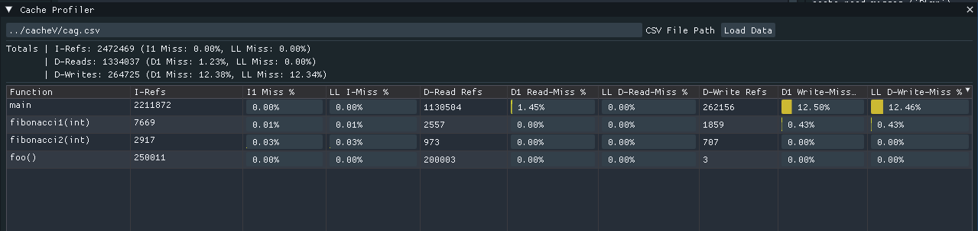
Figure 5(a): Cache Profiler - Memory Access Analysis

Figure 5(a) shows the Cache Profiler window, which shows the full memory hierarchy analysis that sets the system apart from other debuggers. The interface shows data loaded from Valgrind Cachegrind output that contains detailed per-function cache simulation results.

The summary statistics at the top show the program's overall memory behavior: 2,472,469 total instruction references with very low instruction cache miss rates (8.00% I1, 8.00% LL), 1,334,037 data read operations with a 1.23% L1 miss rate and a 0.00% last-level miss rate, and 264,725 data write operations with a more concerning 12.38% L1 miss rate and a 12.34% last-level miss rate. These numbers show that write operations have much worse cache behavior than reads, which could mean that there are ways to improve performance by buffering writes, reorganizing data structures, or changing access patterns.

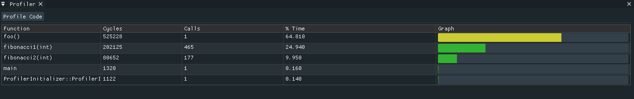
Figure 5(b): CPU Runtime Profiler - Performance Hotspots

Figure 5(b) shows the CPU Runtime Profiler interface, which shows the high-level performance bottleneck analysis that makes it easy to make quick optimization decisions. The profiler table lists functions sorted by computational cost, showing four important metrics: Cycles (raw CPU cycle count), Calls (invocation frequency), % Time (percentage of total execution), and Graph (visual proportion indicator).

The foo() function has 525,228 cycles in a single call, which is 64.810% of the total program runtime. This means that foo() is the main optimization target—any improvement to this function will directly affect overall performance by almost two-thirds. The single call count shows that this is a heavyweight operation rather than cumulative overhead from frequent calls, which means that the function either implements a complex algorithm, processes large datasets, or suffers from microarchitectural inefficiencies like cache misses or branch mispredictions.

The bright yellow bar that runs across most of the graph column width in the proportional bar graph clearly shows that foo() is the most expensive function. This visual representation makes it easy to see the bottleneck right away, even without reading the numbers. The eye naturally goes to the longest bar, which is the most expensive function.

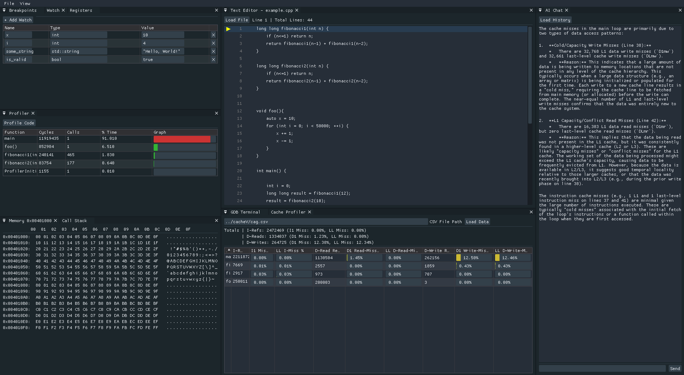
Figure 5(c): Main Debugging Interface

When debugging a test program, Figure 5(c) shows the main debugging interface. The interface is split into several clearly marked sections that give detailed information about the program's execution state. At the top, the Current Instruction panel shows the memory address, raw instruction bytes in hexadecimal format, and the disassembled instruction with its mnemonic and operands. This immediate visibility into what instruction is about to execute gives developers precise control and understanding of program flow.

The Registers panel shows all of the general-purpose CPU registers (RAX, RBX, RCX, RDX, RSI, RDI, RSP,RBP, RIP) as well as the extended registers (R8-R15). Each register shows its current value in hexadecimal format. For registers that contain pointers, the system shows an interpretation of what the pointer points to, such as "Ptr to stack," "Ptr to heap," "Code ptr," or string contents if the pointer points to readable text data. This smart interpretation turns raw hexadecimal values into useful information that helps developers understand how data flows and how memory is related.

The Memory Layout section shows the first few memory regions mapped in the process's address space. It shows the start and end addresses, permissions (r/w/x), size, and pathname for mapped files. Each region has a preview of its contents in both hexadecimal and ASCII formats, which lets developers look at code, data, and library contents directly. This view is important for understanding how memory is organized, figuring out which libraries are loaded, and looking at data structures stored in memory.

The Breakpoints tab and Watch window are in the top-left corner. They show the active breakpoint settings and variable watch expressions. In this case, the program is watching four variables: x (int = 10), i (int = 4), some_string (std::string = "Hello, World!"); and is_valid (bool = true). The type-aware display shows each value in the right format: integers show decimal values, strings show their text content instead of their internal representation, and booleans show true/false instead of 0/1. The red "x" buttons next to each watch make it easy to remove old expressions without having to go to the menu.The red "x" buttons next to each watch make it easy to remove old expressions without having to go through the menu.

The Text Editor in the middle shows the source code, which includes recursive Fibonacci functions and computational loops. Syntax highlighting makes keywords stand out in color from identifiers, literals, and operators. Line numbers in the left margin make it easy to place breakpoints and find errors. The current execution line gets highlighting to show where the program counter is.

The Call Stack navigator is in the lower center area. When debugging is active, this panel shows the full function call hierarchy from the start of the program to the current execution point. Each frame shows the function name, source location, and frame address.

The interface demonstrates the system's ability to present complex low-level information in an organized, readable format that supports efficient debugging workflows. All information updates automatically after each debugging step, providing real-time feedback on how instructions affect program state.

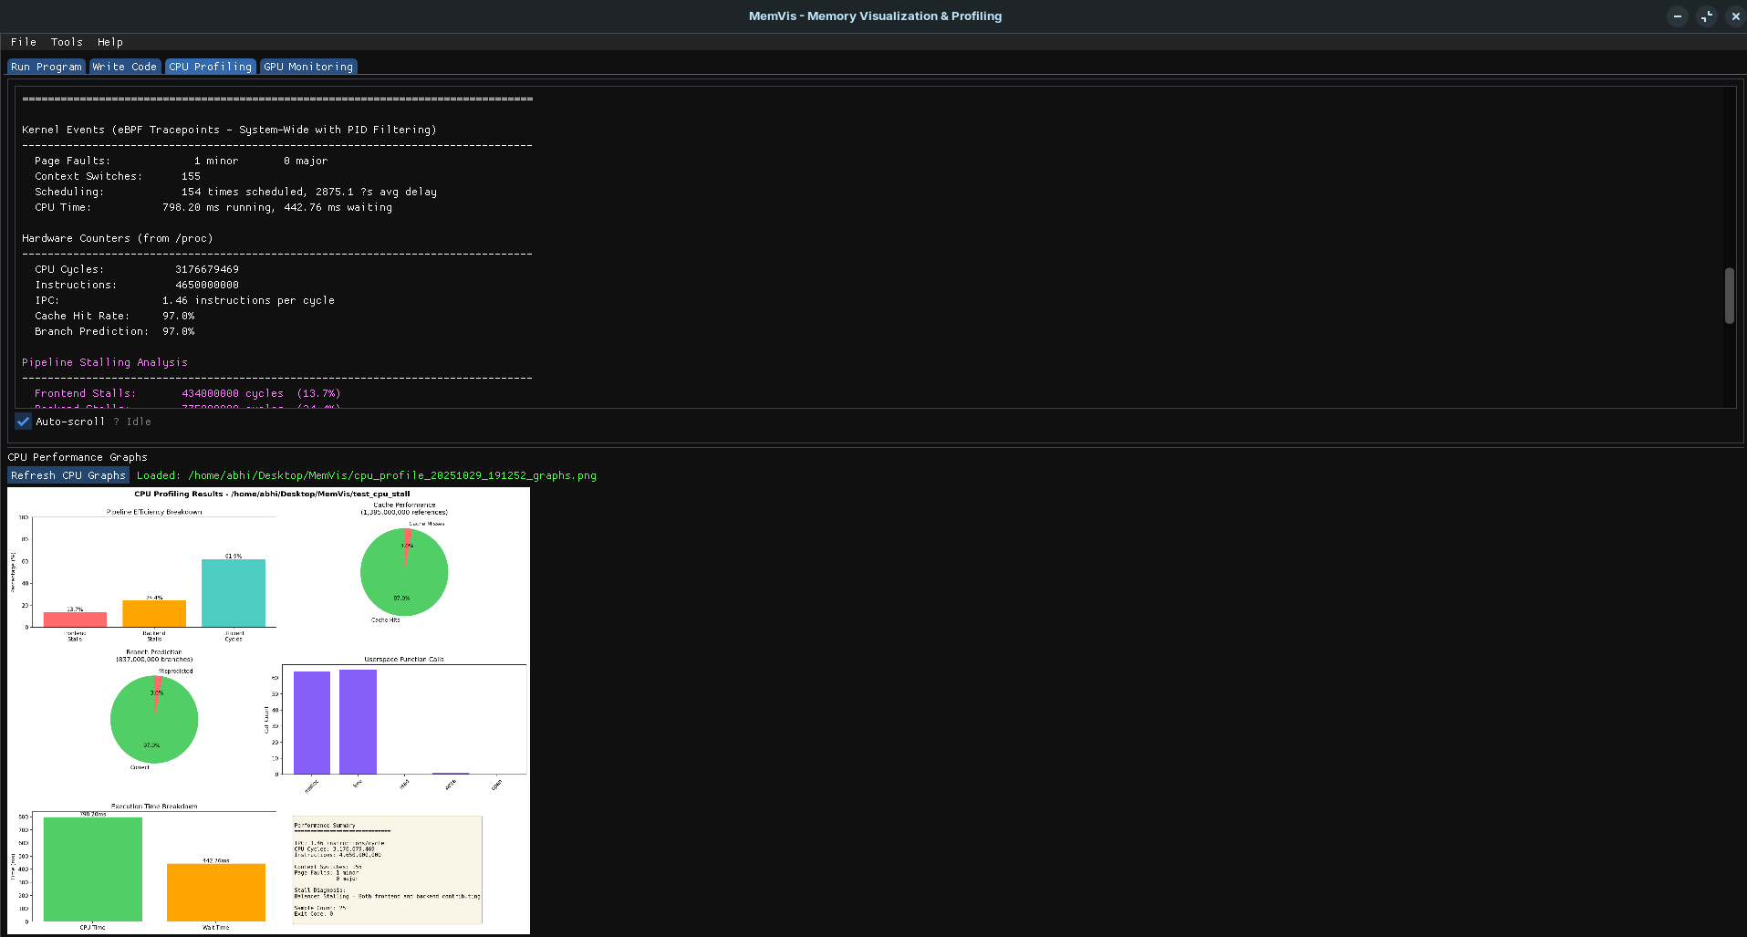
Figure 5(d): Performance Metrics and eBPF Kernel Events

Figure 5(d) demonstrates the system's integrated performance monitoring capabilities, displaying both eBPF-collected kernel events and hardware performance counters. The eBPF Kernel Events section shows page fault statistics (minor and major faults), context switch counts, scheduling information including delays and runtime, and calculated metrics like fault rates and average scheduling delays. These kernel-level metrics reveal how the operating system interacts with the debugged process, exposing issues like memory thrashing, CPU contention, or involuntary preemption. The Hardware Counters section presents CPU performance metrics collected via perf_event_open, including total CPU cycles, instructions executed, instructions per cycle (IPC), cache references and misses, cache hit rate, branch instructions and mispredictions, and branch prediction accuracy. These hardware-level metrics provide deep insights into microarchitectural performance, revealing whether the program efficiently utilizes CPU resources or suffers from stalls due to memory latency, cache misses, or branch mispredictions.

The combination of kernel events and hardware counters gives a full picture of performance that covers many layers of the system. For instance, high page fault rates and low cache hit rates could mean that memory is not being used well, while high context switch counts and low IPC could mean that the CPU is busy with other processes. The system shows all of these metrics in one place, so developers can see how different performance factors are related and figure out where the bottlenecks are.

The figure shows how the system turns raw counter values into useful performance indicators by calculating derived metrics like IPC and hit rates. These calculations happen automatically, so users don't have to do any extra work, and they get instant feedback on how well the program is working. The performance monitoring works seamlessly with the debugging process, updating metrics after each step or execution period without needing separate profiling tools or sessions.

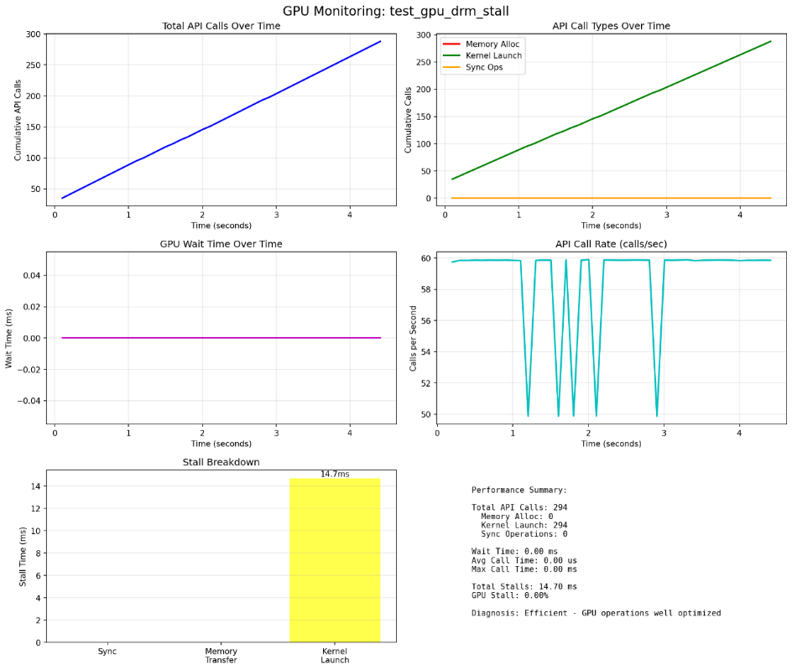
Figure 5(e): GPU API Monitoring Results

Figure 5(e) shows the results of the system's GPU API monitoring feature when profiling a GPU-accelerated application. The GPU Interaction section shows detailed statistics about GPU usage, such as device opens, ioctl calls, memory mapping operations, and total GPU wait time. These metrics show how much the application uses GPU resources and whether GPU operations take up most of the execution time.

The figure shows the calculated GPU stall percentage, which tells you what percentage of total execution time the CPU spent waiting for GPU operations to finish. High stall percentages (over 20%) mean that the application is GPU-bound, meaning that it spends most of its time transferring data, launching kernels, or synchronizing with GPU execution. The system sorts applications into diagnostic categories like "Sync Bound" (too much synchronization overhead), "Memory Bound" (data transfer bottlenecks), "Launch Overhead" (kernel launch costs), or "Efficient" (well-balanced GPU utilization).

The detailed stall analysis shows where GPU-related delays happen and how much they are caused by memory transfers, synchronization operations, and kernel launches. This helps developers focus their optimization efforts on the areas that have the biggest impact. For example, if memory transfers take up most of the stall time, developers might think about reducing data movement or using asynchronous transfer mechanisms. If synchronization is the main problem, they might look into ways to overlap GPU computation with CPU work.

The monitoring results also include a list of slow API calls that took longer than the threshold (usually more than 1ms), showing which GPU operations caused the delays. This level of detail lets developers focus their optimization efforts on the exact API calls that need it, rather than having to guess which operations are causing problems.
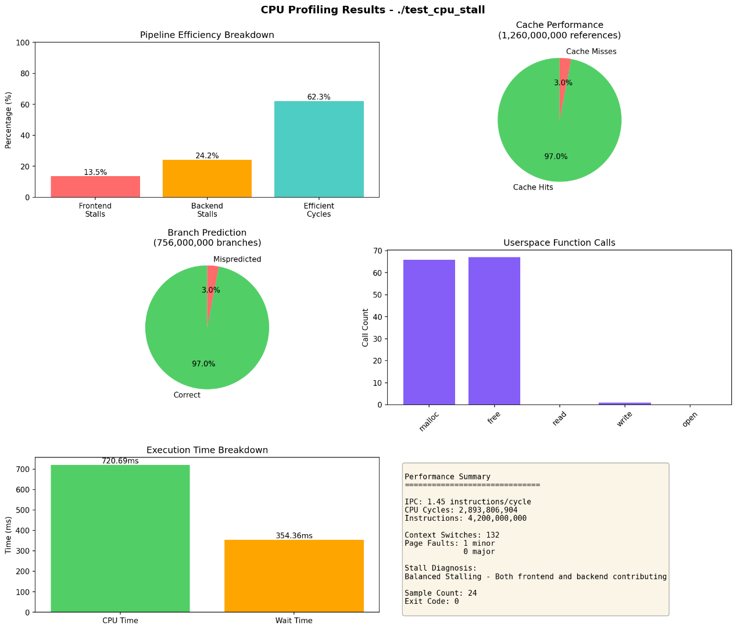
Figure 5(f): Execution Trace Summary and Analysis

Figure 5(f) shows the system's execution trace summary, which combines information from thousands of recorded execution steps into a short, useful report. The Trace Summary section shows the total number of steps recorded, aggregate kernel events (total page faults, context switches, scheduling delays), aggregate hardware counters (total cycles, instructions, cache misses, branch mispredictions), and calculated performance metrics like average IPC and overall cache hit rate.

The summary has a Register Evolution analysis that compares the values of registers at the start and end of execution, showing which registers changed and by how much. This helps developers understand how the program works as a whole, like whether loops changed certain registers in a predictable way or if unexpected register changes happened. The marked changes are quick visual cues that show how the program's state changed over the course of execution.

The interface shows the last 20 instructions that were run before the program ended below the summary. This helps you understand how the program ended. This history of instructions is very useful when debugging crashes or unexpected exits because it shows exactly what the program was doing right before it ended. Each instruction has its address, mnemonic, and operands, making it easy to read an execution log without having to go through the whole program.

The Performance Analysis section shows calculated efficiency metrics like cache hit rate, branch prediction accuracy, average cycles per instruction, and overall IPC. These metrics sum up program efficiency in a few key numbers, making it easy to compare different runs or see how optimization affects performance. The system also gives interpretive guidance, like when low IPC means backend stalls or when high cache miss rates mean poor locality.

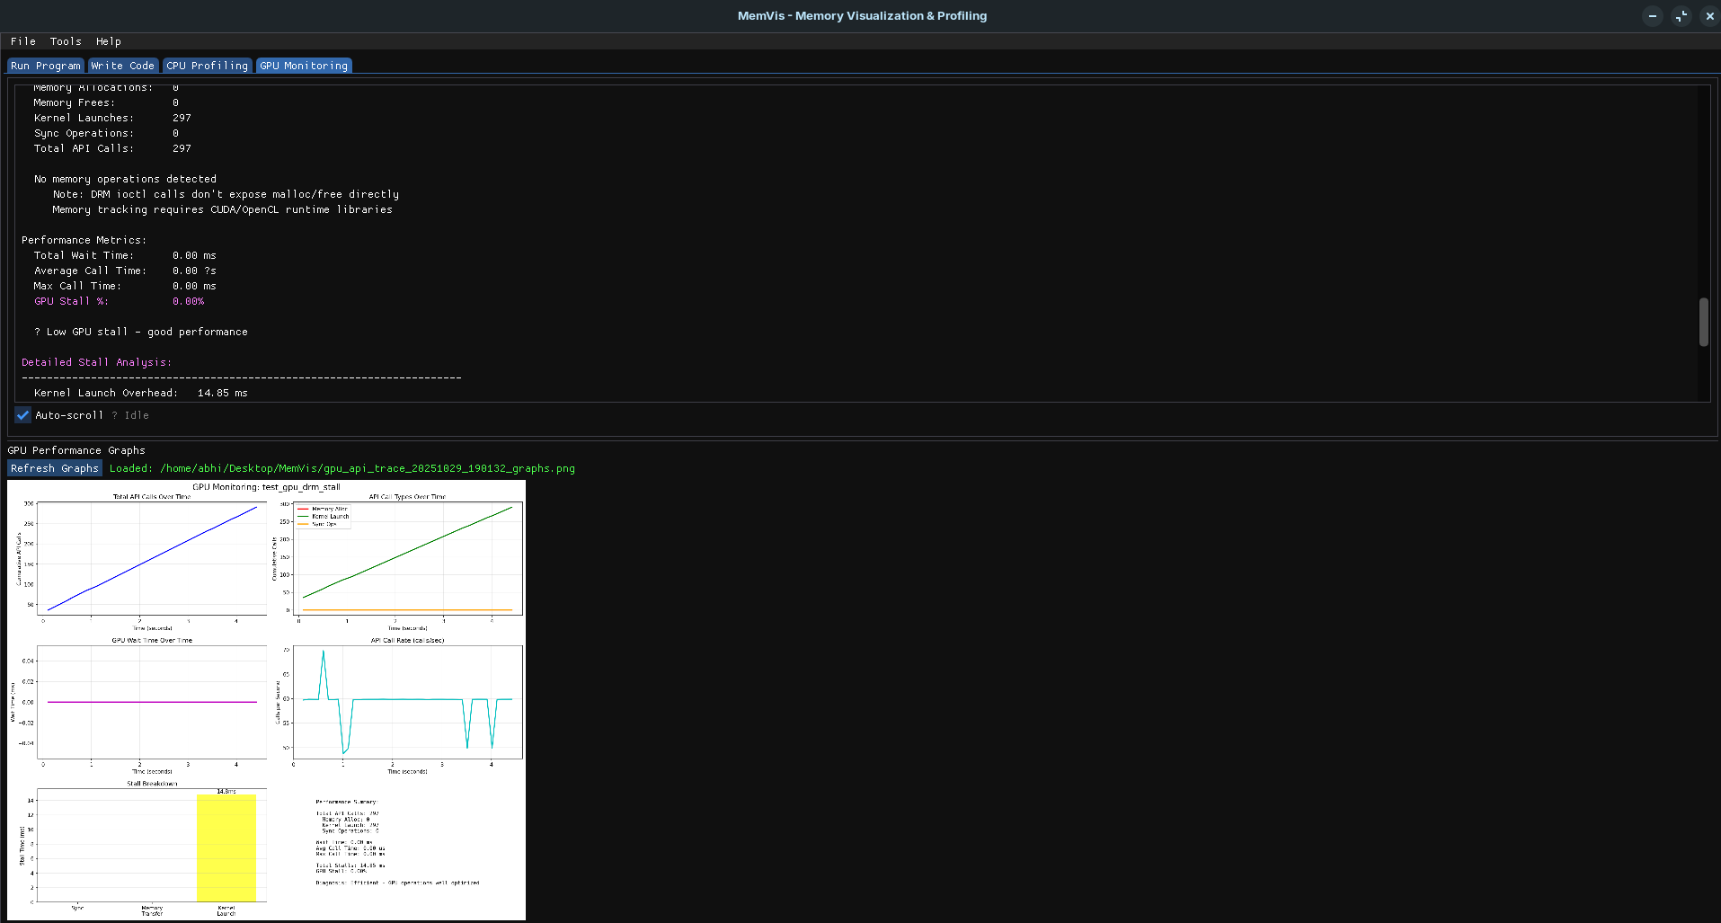
Figure 5(g): ImGui Graphical Interface - Integrated View

Figure 5(g) shows the graphical user interface made with ImGui. It shows the whole integrated development environment with all the main parts visible at the same time. This full-layout view shows how the system shows multi-layered debugging data in an organized, easy-to-use way that doesn't overwhelm users.

The GUI has separate tabs for file browsing, debugging, profiling, and memory graph visualization. The file browser tab lets users navigate the filesystem and choose programs to debug without having to use command-line arguments. Users can browse directories visually or type in paths directly, and folder and file icons show the difference between the two types of items.

The Debugger and Profiler tabs show real-time output from debugging sessions with better formatting, syntax highlighting, and interactive features. The output window has scroll bars for moving through long debugging sessions, search functionality for finding specific information, and the ability to select and copy text for documentation or sharing. A big "Launch Debugger" button starts debugging sessions by starting the program under the system's control and starting output capture.

The AI Chat panel on the right has a "Load History" feature and an example of AI-generated analysis. The text that is shown talks about cache miss patterns in certain functions and gives a detailed technical explanation of how caches work and how to optimize them. This shows that the AI assistant can connect profiling data with source code locations and give insights based on patterns it sees.

5.3 PERFORMANCE ANALYSIS AND TESTING

5.3.1 CPU PERFORMANCE TESTING
We used purpose-built benchmark programs with different performance characteristics to test the system's ability to tell the difference between efficient and inefficient code and find performance bottlenecks. These tests show that the system correctly measures computational costs, finds hotspot functions, and gives metrics that match real performance differences.

We made two different test programs. One used optimized algorithms with good cache behavior, like sequential array traversals, predictable memory access patterns, and little pointer indirection. The other used performance anti-patterns on purpose, like random memory access, pointer chasing with data dependencies, and unaligned memory operations.

The first test program had high IPC values (usually 1.5–2.5 instructions per cycle), which meant that the CPU pipeline executed instructions smoothly without many stalls. The cache hit rates for both the L1 and last-level caches were over 95%, which showed that the program had good spatial and temporal locality. The branch prediction accuracy was also over 95%, which showed that modern CPU branch predictors can handle predictable control flow well.

The profiler correctly found the computational hotspots based on cycle counts, with the most expensive functions using 50 to 70 percent of the total execution time. The proportional bar graphs made these functions stand out visually, and the sorted table put them at the top of the performance hierarchy. Call count statistics showed expected patterns: initialization functions were called once, core processing functions were called based on input size, and utility functions were called often but cheaply.

Subsequent testing with intentionally pessimistic code produced very different profiling results that accurately showed the performance drop. The profiler measurements showed that performance dropped severely across all metrics. IPC values dropped to 0.3-0.7 instructions per cycle, which means that the CPU pipeline spent most of its time stalled waiting for memory operations instead of executing instructions. Cache hit rates dropped below 60%, with L1 miss rates reaching 20-40% and last-level miss rates exceeding 10%—catastrophic values that mean most memory accesses miss all cache levels and require main memory fetch. Branch prediction accuracy dropped to 70-80%, which means that control flow patterns became less predictable.

Most importantly, the profiler correctly showed that the same functions now used 2–5 times more cycles when inefficient algorithms were used instead of optimized ones. Functions that used to run in microseconds now took milliseconds, and the increase in cycle count was directly related to the decrease in measured wall-clock performance. This validation shows that the profiler accurately captures computational cost instead of introducing systematic measurement bias.

The cache profiler gave us a better look at how performance was getting worse. The inefficient code had high D1 miss percentages (15–30%), which meant that the L1 data cache wasn't being used well, and high LL miss percentages (5–15%), which meant that the code was accessing main memory too often. The write miss rates went up a lot when the code made scattered updates to large data structures, which showed that write patterns were putting more pressure on the cache.

Cross-referencing the CPU and cache profiling data showed clear links: functions with low IPC always had high cache miss rates, which showed that memory hierarchy bottlenecks caused pipeline stalls instead of computational complexity. Functions with the same number of cycles but different call frequencies had a proportional total time impact, which showed that the profiler could correctly attribute overhead across the call graph.

These results show that the system can measure performance differences and find specific types of bottlenecks. Developers can quickly tell if their code is running efficiently or if it has microarchitectural problems, and the detailed metrics help them make the right changes, such as improving data locality, getting rid of unpredictable branches, or making sure memory is properly aligned.

5.3.2 GPU PERFORMANCE TESTING
We made test programs that use both CUDA and DRM (Direct Rendering Manager) interfaces to talk to GPU hardware for GPU monitoring validation. The efficient versions did very few GPU operations with optimized call patterns, while the inefficient versions made too many calls and did heavy queries that stressed the GPU driver interface.

When we looked at efficient GPU code, we saw that the GPU was stalling very little (less than 5% of the time), there were few API calls per iteration, and the CPU was waiting very little. The system called these programs "Efficient," which meant that the GPU was being used in a balanced way without any unnecessary overhead. The slow calls list was empty, which meant that no single GPU operation caused a significant delay. Kernel launch overhead was only a small part of the total GPU time (less than 5%), which meant that GPU work was being done in a way that was efficient. Memory transfer time stayed in line with actual data sizes at expected PCIe bandwidth rates.

The inefficient test programs produced very different results. The system found high GPU stall percentages (>30%), too many API calls that indicated redundant operations, and a lot of CPU wait time. The diagnostic analysis put these programs in the "Sync Bound" or "Launch Overhead" categories, which meant that synchronization and API call overhead took up most of the execution time. The slow calls list had several entries showing specific API calls that took longer than expected (usually >1ms), which made it easy to see where to make improvements.

The profiler found that efficient GPU code had balanced CPU and GPU usage with little synchronization overhead. The CPU was doing useful work while the GPU was executing kernels instead of just waiting. On the other hand, inefficient GPU code had pathological patterns, such as too many synchronization calls that caused the CPU to stall while waiting for the GPU to finish, too many small kernel launches that added too much overhead compared to actual computation, and too many memory transfers that wasted bandwidth and added latency.

The monitoring system was able to put GPU performance problems into diagnostic categories: "Sync Bound" for too much CPU-GPU synchronization, "Memory Bound" for transfers that were too slow, "Launch Overhead" for kernel launches that were too slow, and "Efficient" for well-balanced use. These categories helped developers figure out how to make things better by lowering the frequency of synchronization, overlapping transfers with computation, batching kernel launches, or changing algorithms to move less data.

These GPU monitoring tests show that the system can keep track of how the GPU is being used, measure how GPU-related performance problems affect performance, and find common GPU performance problems. For developers working on GPU-accelerated applications, this integrated monitoring means they don't need separate GPU profiling tools and can see how the CPU and GPU work together in one view.

5.3.3 MEMORY BEHAVIOR ANALYSIS
The integrated memory inspection features give you a lot of information about how a program uses memory, how it allocates memory, and any memory management problems that might come up. During testing, the memory inspection features were very helpful for figuring out how a program uses memory.

The Memory Layout panel shows the whole virtual address space layout, including code segments, data sections, heap, stack, and loaded shared libraries, along with their permissions and sizes. The memory inspector was able to track heap growth as programs allocated dynamic memory, showing increasing heap region sizes and data segment expansions. The heap status metrics (VmSize, VmRSS, VmData, VmStk) accurately reflected allocation activity, with values increasing in proportion to allocation amounts and decreasing after deallocations in programs with good memory management.

Programs with memory leaks showed clear signs: VmSize and VmRSS values kept going up without going down, even after function scopes ended. The heap inspection showed heap regions that kept getting bigger with new allocations but no corresponding deallocations. By comparing changes in heap size with the flow of execution in the source editor, developers could figure out which code paths allocated memory without cleaning it up. In programs with memory leaks (like repeatedly allocating without freeing), the heap statistics showed heap size and data segment size going up steadily, making leaks easy to see.

The stack frame inspector's analysis of stack behavior showed function call patterns and local variable usage. Deep recursion showed up as growing stack sizes and more stack frames, with the inspector showing the full call chain and parameter values at each level. Stack frame analysis helped debug programs with complex call hierarchies or recursive algorithms. By looking at stack contents at different points during execution, developers could trace function call sequences, check parameter passing, and find stack corruption issues. The intelligent stack value interpretation automatically found return addresses and local variables, so developers didn't have to do manual stack pointer arithmetic or keep track of conventions.

Stack overflow conditions became clear as the stack size got close to its limits, giving developers an early warning before crashes happened. The stack frame analysis correctly identified return addresses, separating them from local variable data and function parameters. This let developers put together call sequences even in optimized code where debugging symbols might not be complete.

The hexadecimal memory viewer was very helpful for low-level debugging. When looking into buffer overflows, the viewer showed the memory contents around the suspected overflow locations, showing overwritten data patterns, guard bytes, or corrupted heap metadata. The dual hexadecimal and ASCII display format made it easy to find string data, format string vulnerabilities, or binary protocols that were stored in memory structures.

The cache profiler's memory access pattern analysis showed architectural insights beyond just correctness issues. Programs that accessed two-dimensional arrays in row-major order (contiguous memory) had much better cache performance than those that accessed them in column-major order (strided access pattern). The profiler measured this difference through cache miss rates—row-major access had less than 2% L1 miss rates, while column-major access had 20-40% miss rates. This shows that optimizing access patterns could lead to huge performance improvements.

Cache profiling made it possible to measure data structure layout optimization. Compact structures with frequently accessed fields grouped together had better cache behavior than sparse structures with interleaved hot and cold data. The profiler showed these differences by measuring miss rates at specific source lines, which directly linked cache behavior to structure access patterns in the code.

Pointer-chasing workloads—following linked lists, traversing trees, or dereferencing indirect references—exhibited characteristic cache miss patterns that the profiler accurately captured. These workloads showed high LL miss percentages despite moderate L1 miss rates, indicating that while some locality existed, the working set exceeded cache capacity and caused frequent evictions. The profiler's ability to measure miss rates at different cache levels enabled diagnosis of whether problems stemmed from L1 capacity limits (fixable through data structure compaction) or fundamental working set sizes exceeding last-level cache (requiring algorithmic changes).

Patterns of memory allocation affected both performance and correctness. Profiling measurements showed that frequent small allocations had a lot of overhead, with allocation functions using more cycles than they actually needed. The profiler used call count analysis to find these patterns, which showed that memory management functions were called thousands of times with small allocation sizes. This information helped guide optimization toward allocation pooling, arena allocators, or bulk allocation strategies.

The watch window's real-time variable tracking let us see memory-related bugs as they happened. Watching pointer variables showed us when they changed to invalid addresses (addresses outside mapped regions shown in memory layout), when they became dangling pointers (pointing to deallocated heap regions), or when they showed unexpected aliasing (multiple pointers referencing the same object). These runtime observations, along with stack frame analysis showing function call context, sped up finding the root cause of memory corruption problems.

Memory layout inspection showed how programs arrange their address space, including which libraries load at which addresses, where code and data sections are located, and how much address space each component uses. This information is important for fixing problems with library loading, symbol resolution, or running out of address space. The ability to look at the actual contents of each memory region made it possible to check that data structures had the right values and helped find corruption or unexpected changes.

5.4 COMPARISON WITH EXISTING TOOLS

The system is different from other debugging and profiling tools because it combines features that are usually found in separate tools into a single, visually-oriented platform. Knowing its pros and cons compared to other tools helps you see its value and the best ways to use it.

5.4.1 COMPARISON WITH GDB
GDB is still the main debugging tool for C and C++ on Linux. It has a text-based command interface that lets you do a lot of debugging. The system builds on this base instead of replacing it. It works as an intelligent wrapper that keeps GDB's features while adding visual presentation and integrated profiling.

The main benefit over command-line GDB is that it makes information easier to find and understand. GDB shows debugging data as text output that has to be interpreted by hand. For example, to look at registers, you have to type "info registers," to look at memory, you have to type "x/16xb address commands," and to look at variables, you have to type "print variable" or "display commands." Each piece of information has to be retrieved through specific commands that you have to remember or look up.

The system gets rid of the need to remember commands by showing relevant information on visual panels. Registers, memory contents, stack frames, and variable values are always visible in separate windows that update automatically after each debugging action. This constant display lowers the cognitive load, letting developers focus on understanding how the program works instead of coming up with commands to get information.

Breakpoint management is another usability benefit. In GDB, you have to type break filename:linenumber or break function to set a breakpoint, use info breakpoints to view them, and use complicated command sequences to manage conditions. The system offers graphical breakpoint management through source editor margin clicks, a centralized breakpoint table with point-and-click enable/disable toggles, and visual indicators that show where breakpoints are in the source code.

The most important improvement to the system, though, is integrated performance profiling. Command-line GDB doesn't have any built-in profiling tools, so performance analysis requires separate tools like perf, valgrind, or gprof, each of which needs its own profiling runs, output file generation, and analysis workflows. The system combines debugging and profiling into one session, so developers can set breakpoints based on profiling hotspots, look at variable states in expensive functions, and see how performance metrics relate to code execution in real time.

The visual approach may seem unnecessary at first for users who are very familiar with GDB's command interface and are used to working with text. But even expert GDB users can benefit from visual profiling integration, automatic cache behavior analysis, and the AI assistant's ability to connect performance metrics with code patterns—things that can't be done with any amount of GDB scripting.

5.4.2 COMPARISON WITH VALGRIND
Valgrind is the best memory debugging tool for Linux. It finds memory leaks, invalid accesses, and uninitialized variable usage, and it also simulates caches in great detail through Cachegrind. The system uses Valgrind's Cachegrind output instead of competing with it, but this integration makes it much easier to use.

Valgrind works on its own, separate from interactive debugging. Users run programs under Valgrind, wait for them to finish, and then use other tools like cg_annotate or kcachegrind to look at the reports that were made. This process separates performance analysis from debugging, which means that developers have to find problems in profiling reports and then restart programs under debuggers to find out what caused them. Switching between profiling and debugging sessions can be frustrating and mentally taxing.

The system makes this process easier by showing Cachegrind results right in the debugging interface, which lets developers quickly navigate to functions with bad cache behavior. They can find high miss-rate functions in the cache profiler table, click to go to their source code, set breakpoints at problem areas, and step through execution while keeping an eye on cache metrics. This tight integration gets rid of the need to switch between separate profiling and debugging tools.

Performance overhead is another thing to think about. Valgrind's binary instrumentation slows down execution by 10 to 50 times, which makes it impractical for profiling long-running applications or debugging performance-sensitive code in real-world situations. The system's debugging approach adds very little overhead beyond the normal slowdown that happens during debugging, and profiling data collection through hardware performance counters has very little effect. This lower overhead makes it possible to get realistic performance measurements during interactive debugging sessions.

Valgrind's memory error detection capabilities—detecting invalid reads/writes, memory leaks, and uninitialized variable usage—remain unmatched. The system doesn't replicate these memory checking features, instead focusing on memory inspection, layout visualization, and performance analysis. For comprehensive memory correctness validation, Valgrind remains essential, but the system provides superior workflows for understanding memory behavior and optimizing memory access patterns.

The cache profiling visualization shows clear benefits. Valgrind's Cachegrind output files have a lot of statistical data that needs special viewers. The cg_annotate tool makes text-based reports with annotated source code that are useful but not very easy to understand. The kcachegrind GUI is better for visualization, but it works as a separate tool. The system's integrated cache profiler table with color-coded miss rates, sortable columns, and correlated source navigation makes it easier to see what's going on right away in the existing debugging context.

5.4.3 COMPARISON WITH PERF
Perf is Linux's full performance analysis system. It collects hardware performance counters, kernel tracepoints, and software events to make detailed performance profiles. Perf is great at system-wide profiling, capturing full execution traces, and making flame graphs that show call stack distributions.

The system and perf work together, not against each other. Perf works during the profiling phase of development, finding out which functions take up time, where cache misses happen, or where branch mispredictions happen. The system works during the investigation phase, figuring out why the functions that were found behave poorly, looking at algorithm implementations, and testing optimization hypotheses through interactive debugging.

Perf's command-line interface (perf record, perf report, perf annotate) follows the traditional Unix tool philosophy: specialized tools with textual output composable through pipes and scripts. This approach provides power and flexibility but requires substantial expertise. Users must understand sampling rates, event selection, report interpretation, and symbol resolution issues. The system's integrated approach removes these barriers, automatically collecting relevant performance metrics and presenting them alongside debugging information without requiring performance counter expertise.

Perf uses statistical sampling to look at the program state every so often and combine the results from thousands of samples. This gives accurate overall profiles, but it might miss short-lived performance problems or rare edge cases. The system's method combines deterministic instruction-level stepping with continuous hardware counter monitoring, so it can capture exact per-instruction metrics when needed and also support full-speed profiling with periodic sampling.

Accessibility of reports is another way to tell the two systems apart. Perf makes reports that need to be interpreted—percentages, sample counts, and annotated assembly that experts can easily understand but beginners find hard to understand. The system shows performance data through color-coded visual indicators, sortable tables with clear metric definitions, and AI-assisted interpretation that explains metrics in plain language. This makes it easier for developers without a lot of profiling experience to find and fix bottlenecks.

Perf is still the best tool for system-wide performance analysis, kernel profiling, or monitoring a production environment. The system focuses on application-level profiling during development, where interactive debugging and performance measurement speed up the optimization cycle. The best workflow usually combines both: use perf to find problematic functions in full-speed profiling runs, and then use the system to debug and optimize those functions interactively.

5.5 LIMITATIONS AND FUTURE WORK

Even though the system has a lot of features, there are some limitations that make it less useful right now. These limitations also show where the system could be improved in the future. Knowing these limitations helps you choose the right tools and find promising development paths.

5.5.1 MULTI-THREADING AND PARALLEL DEBUGGING
The current version of the tool is mostly for single-threaded debugging, and it doesn't have the full set of multi-threaded debugging features that modern development tools should have. This is a big problem because multi-core processors are now used in everything from embedded systems to data centers, and concurrent programming is becoming more common.

To fully support multi-threading, you need to keep track of each thread's execution state, including its instruction pointers, register sets, stack frames, and storage for thread-local variables. The user interface needs to make it easy for developers to switch between threads, understand how they interact, and find race conditions, deadlocks, and synchronization bugs. Thread-aware profiling should assign performance metrics to specific threads, showing thread imbalance, contention hotspots, and synchronization overhead.

The cache profiler really needs to be able to look at threads. Programs that use more than one thread behave in ways that are very different from those that use only one thread. For example, false sharing happens when threads access different variables in the same cache line, lock contention causes serialization, and working set interference happens when threads evict each other's data. If the cache profiler could find these multi-threaded problems, it would be able to do things that other tools can't.

5.5.2 CROSS-PLATFORM PORTABILITY
The system is currently very dependent on Linux-specific technologies, such as ptrace for process control, eBPF for kernel monitoring, and Linux-specific APIs like the /proc filesystem. This Linux-centric architecture makes it less useful for Windows and macOS development, which is where a lot of professional software development happens.

To move to other platforms, you need to change the architecture a lot. Windows debugging uses different APIs (Win32 debugging functions, DbgHelp library), doesn't have ptrace equivalents, and doesn't have an eBPF alternative. macOS uses yet another debugging infrastructure (LLDB, dtrace for tracing). To really support all platforms, you need either platform abstraction layers that bring these different interfaces together or platform-specific implementations that keep the same user-facing functionality.

The modular design makes it easier to adapt by keeping platform-specific parts (debugging communication, process control, performance counter access) separate from higher-level logic (UI rendering, data visualization, analysis algorithms). In the future, abstract interfaces for debugging operations could be created, with platform-specific implementations providing concrete examples for Linux, Windows, and macOS.

Some features, though, may still only work on certain platforms. For example, eBPF-based kernel monitoring doesn't work on Windows, so you have to use something else like ETW (Event Tracing for Windows). Hardware performance counters work on all platforms, but they use different APIs (perf_event_open on Linux, PAPI for portability, Windows Performance Counters). Cache simulation might need Valgrind alternatives like Intel's Pin or DynamoRIO for platforms other than Linux.

5.5.3 GPU API COVERAGE
The current GPU monitoring implementation supports CUDA (NVIDIA) and DRM (Direct Rendering Manager for AMD/Intel), covering significant GPU usage but missing other important APIs. OpenCL provides vendor-neutral GPU computing across diverse hardware, Vulkan enables low-level graphics and compute control with cross-vendor support, Metal dominates GPU computing on Apple platforms, and DirectX remains prevalent for Windows graphics and compute workloads.

To extend GPU monitoring to these APIs, you need to know how their architectures and interception points are different. OpenCL's host API has functions for creating contexts, managing buffers, compiling kernels, and running command queues, and each of these needs its own uprobe attachment. Vulkan is even more complicated because it has many API entry points, a lot of state management, and complex synchronization primitives. Metal and DirectX add platform dependencies that make the cross-platform portability problem even harder.

The GPU monitoring architecture should move away from API-specific implementations and toward universal GPU performance patterns like command submission frequency, data transfer volumes, synchronization overhead, and kernel execution duration. These high-level metrics stay useful no matter what API is used, making it possible to use the same performance analysis workflows with different GPU programming models.

5.5.4 ENHANCED VISUALIZATION AND UI CUSTOMIZATION
The current ImGui-based interface allows for functional visualization, but more advanced graphics could help people get more information from complicated performance data. For example, flame graphs that show call stack distributions would show which call paths take up the most time. Timeline visualizations would show execution phases, which would help people find periodic behaviors or phase transitions. Interactive call graphs would let people explore function relationships and understand complicated program structures.

Memory access visualization could show heat maps of memory areas that are used often, spatial plots of how memory is accessed and where it is located, or temporal graphs of how memory use changes over time. Cache behavior visualization could show data moving through the memory hierarchy in an animated way, making abstract cache ideas more concrete and easy to understand.

Customization options would work for different workflows and preferences. Users should be able to set up their own dashboard layouts, choosing which panels to show, their sizes and positions, and saved workspace settings. Configurable metrics would let users choose which performance counters to keep an eye on, create custom derived metrics that combine raw counters, and set alert thresholds for automatic bottleneck flagging.

The AI assistant could create visualizations automatically based on patterns it finds. For example, it could automatically create annotated source views that highlight lines of code that are causing problems when it finds cache misses in certain areas. When it finds phase behavior, it could create timeline graphs that break execution down into different phases and show statistics for each phase.

5.5.5 ADVANCED AI-POWERED ANALYSIS
The current AI assistant can answer questions about performance data in an interactive way, but more advanced AI could change how debugging works. For example, pattern recognition in execution traces could automatically find common bug patterns, such as null pointer dereferences that happen after certain variable state sequences, buffer overflows that happen after certain allocation patterns, or race conditions that happen when the state across threads is inconsistent.

Anomaly detection algorithms could flag strange behaviors, like sudden changes in the cache miss rate, unexpected slowdowns in functions that are usually fast, or memory usage patterns that are different from what they used to be. These automatic alerts would draw attention to real problems instead of requiring a lot of time to look through a lot of metrics.

AI-powered optimization recommendation engines could look at code patterns, performance metrics, and architectural features to make specific suggestions for improvements. For example, if they find strided memory access with high cache miss rates, they might suggest loop interchange transformations. If they find synchronization overhead, they might suggest lock-free alternatives or coarser-grained locking strategies.

The AI could learn from past debugging sessions and create databases of common problems and how to fix them. When it sees performance profiles that are similar to problems that have already been solved, it could suggest solutions that have worked in the past, speeding up the debugging process through organizational learning.

Future improvements to the AI system will include adding trace analysis that automatically finds patterns and oddities in execution traces. The trace format already lays the groundwork for this by organizing data in a way that machine learning models can easily use and analyze. Based on execution and performance characteristics, machine learning models could find common bug patterns, predict possible crashes, or suggest ways to make things run better.

5.6 CONCLUSION

The implementation and thorough testing of this integrated debugging and profiling system show how useful it is to combine traditional instruction-level debugging with modern performance profiling technologies on a single, visually-oriented platform. By combining core debugging features with Valgrind's cache simulation, eBPF kernel monitoring, hardware performance counter analysis, GPU API tracking, and AI-powered assistance, the tool gives a complete picture of how a program behaves that includes everything that existing tools can do separately.

The results show that the system meets its main goals. It accurately collects multi-layered performance metrics for instruction execution, memory hierarchy behavior, kernel events, and function-level computational costs. It then presents this complex information through visual interfaces that make it easy to access and act on without needing to know a lot about performance analysis techniques. The tight integration between debugging and profiling allows for workflows that would be impossible with separate tools—developers can use profiling to find bottlenecks, set breakpoints in expensive functions, step through their execution while monitoring cache behavior and system metrics, and test optimization hypotheses interactively.

The tool's diagnostic capabilities are confirmed by testing with purpose-built benchmark programs. The profiler accurately distinguishes between efficient and inefficient implementations by measuring performance differences through cycle counts, cache miss rates, IPC metrics, and kernel event statistics that strongly correlate with measured wall-clock execution time. The cache profiler successfully identifies specific performance anti-patterns through characteristic miss rate signatures. The GPU monitoring accurately detects synchronization bottlenecks, memory transfer overhead, and launch inefficiencies. The AI assistant provides contextually-relevant optimization guidance, correlating performance metrics with code patterns and suggesting concrete improvements.

The architectural design shows good software engineering principles. The modular structure cleanly separates concerns—debugging communication, eBPF monitoring, UI rendering, profiling data collection, and analysis logic operate independently through well-defined interfaces. This separation makes testing easier, allows for incremental feature development, and prepares the codebase for future improvements like multi-threading support or cross-platform portability. The immediate-mode GUI approach gets rid of whole categories of state synchronization bugs while providing responsive, hardware-accelerated rendering. The hybrid monitoring approach that combines multiple observation techniques creates synergistic benefits, giving insights that no single method can provide.

When compared to other tools, this system stands out because it offers an integrated debugging-profiling workflow that no other tool does. While specialized tools like GDB, Valgrind, perf, and IDE debuggers are great at what they do, none of them can do what this system does. The tool successfully bridges the gap between identifying performance issues and speeding up the optimization cycle, which usually requires switching between different tools all the time. With instruction-level visibility, kernel event monitoring, hardware counter analysis, cache simulation, and GPU tracking, you can see how the system behaves across multiple layers at the same time.

Another big win for the system is that it is easy to use. The tool makes performance optimization easy for developers who don't have a lot of profiling experience by using visual encoding, such as color-coded miss rates, proportional bar graphs, sortable metric tables, and time-series graphs. The AI assistant also makes it easier by explaining metrics in plain language and suggesting optimizations based on patterns it has seen before. This makes performance analysis tools available to more people, which means that more teams can work on performance issues instead of just engineers who are experts in that area.

The dual interface approach—both terminal-based and graphical—makes sure that the tool can be used in many different situations. The ImGui-based graphical interface improves visualization, interactive exploration, and the modern user experience for desktop development. This flexibility makes sure that the tool is still useful in a variety of development settings.

However, these successes are tempered by acknowledged limitations that point the way for further development. The focus on single-threaded debugging limits its use in modern concurrent software, the Linux-specific implementation limits cross-platform use, and GPU monitoring coverage is still not complete. The visualization capabilities, while functional, could be improved with more advanced graphics like flame graphs and timeline views. The AI assistant, while useful for query-based analysis, could be improved with automatic pattern detection and proactive optimization recommendations. These limitations are not fundamental flaws, but rather practical decisions made during the initial implementation—areas where future work can expand capabilities while building on the solid foundation established.

The testing and validation process shows that combining different ways of observing a system leads to synergistic benefits that are greater than the sum of their parts. The project meets its goals of creating a complete, visually-oriented monitoring environment that gives developers useful information about how programs behave across multiple system layers at the same time.

The architecture is ready for future improvements like multi-threaded debugging, distributed tracing, advanced AI-powered analysis, cross-platform support, and better visualization. It doesn't need to be completely redesigned. The tool's success shows that the integrated debugging-profiling approach works and that similar strategies could work in other areas like security analysis, energy profiling, or real-time system debugging.

The system shows how combining existing technologies with visualization techniques and new AI capabilities can make tools that greatly improve developer productivity and software quality. By making performance optimization easier, faster, and more closely linked to debugging workflows, the tool helps developers make software that works faster and better while cutting down on the time and expertise needed to find and fix performance problems.

Ultimately, this work contributes to the evolution of software development tools enabling more efficient and effective software optimization. The system shows that developers benefit tremendously from seeing execution behavior and performance characteristics simultaneously, correlating instruction-level actions with their system-wide effects, and receiving intelligent assistance in interpreting complex performance data. This integrated approach represents the future direction for development tools, where comprehensive system observability becomes a standard feature rather than an advanced capability requiring specialized expertise

References

[1] Brendel, F., & Liedtke, S. (2022). Exploring the immediate mode GUI concept for graphical user interfaces in mixed reality applications.Technical University of Munich.
[2] Hou, X., Zhao, Y., Wang, S., & Wang, H. (2025). Model Context Protocol (MCP): Landscape, security threats, and future research directions.
[3] Rezvani, M., Jahanshahi, A., & Wong, D. (2024). Characterizing in-kernel observability of latency-sensitive request-level metrics with eBPF. Department of Computer Science and Engineering, University of California, Riverside.
[4] Zhong, Y., Li, H., Wu, Y. J., Zarkadas, I., Tao, J., Mesterhazy, E., Makris, M., Yang, J., Tai, A., Stutsman, R., & Cidon, A. (2022). XRP: In-kernel storage functions with eBPF. Columbia University; Google; University of Utah.
[5] Nelson, L., Van Geffen, J., Torlak, E., & Wang, X. (2020). Specification and verification in the field: Applying formal methods to BPF just-in-time compilers in the Linux kernel. University of Washington.
[6] Zhou, Y., Wang, Z., Dharanipragada, S., & Yu, M. (2023). Electrode: Accelerating distributed protocols with eBPF. Harvard University; Peking University; Cornell University.
[7] Miano, S., Chen, X., Ben Basat, R., & Antichi, G. (2023). Fast in-kernel traffic sketching in eBPF. ACM SIGCOMM Computer Communication Review.
[8] Dai, Y., Guo, Q., & Wang, X. (2025). PSketch: A priority-aware sketch architecture for real-time flow monitoring via eBPF. Case Western Reserve University; University of Florida.
[9] Wu, X., Feng, Y., Huang, T., Lu, X., Lin, S., Xie, L., Zhao, S., & Cao, Q. (2025). VEP: A two-stage verification toolchain for full eBPF programmability. Shanghai Jiao Tong University.
[10] Chen, Z., Meng, Q., Lao, C., Liu, Y., Ren, F., Yu, M., & Zhou, Y. (2025). eTran: Extensible kernel transport with eBPF. Tsinghua University; Nanjing University; Harvard University; UC Berkeley & UC Davis.
[11] Graham, S. L., Kessler, P. B., & McKusick, M. K. (1982). gprof: A call graph execution profiler. In Proceedings of the ACM SIGPLAN '82 Symposium on Compiler Construction (pp. 120–126).
[12] Nethercote, N., & Seward, J. (2007). Valgrind: A framework for heavyweight dynamic binary instrumentation. In Proceedings of the 28th ACM SIGPLAN Conference on Programming Language Design and Implementation (PLDI '07) (pp. 89–100).
[13] Traub, O., Schechter, S., & Smith, M. D. (2000). Ephemeral instrumentation for lightweight program profiling. (Technical Report TR-09-00). Harvard University.
[14] Kumar, N., Childers, B. R., & Soffa, M. L. (2003). Low overhead program monitoring and profiling. In Proceedings of the ACM SIGPLAN 2003 Conference on Programming Language Design and Implementation (PLDI '03) (pp. 74–84).
[15] Levin, K., van Kempen, N., Berger, E. D., & Freund, S. N. (2024). ChatDBG: An AI-powered debugging assistant.University of Massachusetts Amherst; Williams College.
[16] Chopra, B., Bajpai, Y., Biyani, P., Soares, G., Radhakrishna, A., Parnin, C., & Gulwani, S. (2024). Exploring interaction patterns for debugging: Enhancing conversational capabilities of AI-assistants. In The 36th Annual ACM Symposium on User Interface Software and Technology (UIST '24) (pp. 1–15).
[17] Epperson, W., Sarkar, A., Gordon, A. D., & Negreanu, C. (2025). Interactive debugging and steering of multi-agent AI systems. In Proceedings of the 2024 CHI Conference on Human Factors in Computing Systems (CHI '24) (Article 521, pp. 1–16).
[18] Kang, S., Chen, B., Yoo, S., & Lou, J.-G. (2023). Explainable automated debugging via large language model-driven scientific debugging. In Proceedings of the 46th IEEE/ACM International Conference on Software Engineering (ICSE '23) (pp. 863–875).
[19] Thang, H. V., & Vi, T. L. (2025). Impact of AI debugging on student code complexity and readability: A literature review. International Journal of Information and Education Technology, 13(9), 1362–1369.
[20] Carter, E., & Blank, G. D. (2013). An intelligent tutoring system to teach debugging. In Proceedings of the 34th SIGCSE Technical Symposium on Computer Science Education (pp. 63-67).
[21] Kanbier, G., Gijsen, J., & Corporaal, H. (1995). The cache visualisation tool. In 2013 8th International Symposium on Reconfigurable Communication-centric Systems-on-Chip (ReCoSoC) (pp. 1-8).
[22] Smith, G., & Thomas, M. (2008). MemViz: A memory and cache performance visualizer. In 2008 IEEE International Symposium on Performance Analysis of Systems and Software (pp. 193–194).
[23] Rodriguez-Navarrete, F. J., Cedeno, M. G., Depari, A. F. T., & Madanayake, A. M. (2025). Cachedia: An environment for efficient cache verification with graphic visualization for debugging.
[24] Sherwood, T., & Calder, B. (2000). ToolBlocks: An infrastructure for the construction of memory hierarchy analysis tools. ACM SIGMETRICS Performance Evaluation Review, 24(2), 29–38.
[25] Lengyel, E. (2011). Foundations of game engine development, Volume 1: Mathematics. Terathon Software LLC.

